Exploration: Ratio and Proportion

Step 1: Launch the Comparing Number Lines: Ratios & Proportions applet.
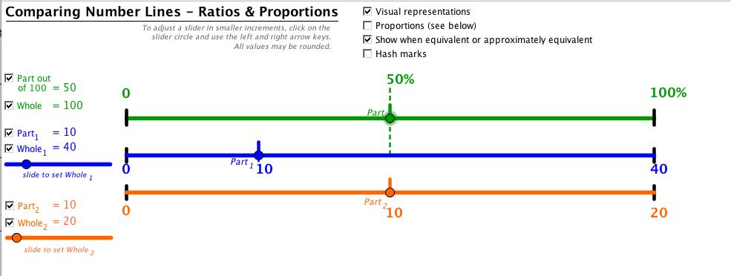

Notice the three number lines.

- The first line (green) represents the whole. 50% of the whole 100% is shown by the dotted line.

- The second line (blue) represents the ratio 10 out of 40.

- The third line (orange) represents the ratio 10 of 20.

Step 2: Set up the following proportion
a) First, uncheck the top part and whole. (Next to the green number line.)
b) Next, click on blue dot below the Whole₁ and adjust it to 5. (Note-if you click on the dot on the slider, you can adjust the size with more precision with the right and left arrows.)
b) Then, adjust the Part₁ to be 3 by clicking on the blue dot and dragging until the value is 3
c) Next, click the orange dot below Whole₂ and adjust it to be 15.
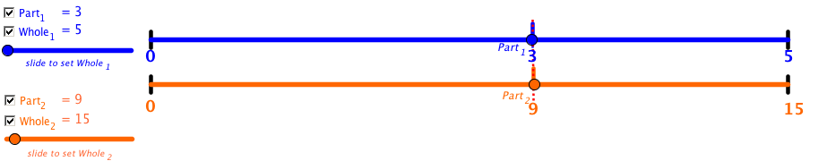

d) Then, click on the checkbox to show the Part₂ to be lining up with the blue Part₁.
(The red line shows up when the two ratios are equivalent and make a true proportion.)
Step 3: Show the proportion on the number line representation
0
5
9
15
0
3

Are these ratios proportional?
Explain if these ratios are equivalent and justify your answer. Use the double number line to support your explanation. Check your prediction on the applet.
1. | ?  Make 6 equal intervals. Top count by 1’s, bottom count by 3’s. | 0  6  3  6  18  0  No, these are not equivalent so they are not proportions. 3 is half of 6 so it is half way on the number line. 6 is only a third of 18 so they are not the same proportion of the line.
2. | ?  Make 4 equal intervals. | 4  0  8  0  5  0
3. | ?  Make 5 equal intervals. | 20  0
4. | ?  Make 5 equal intervals.
5. | ?  Make 4 equal intervals.

6. | ?  Make 3 equal intervals
7. | ?  Make 3 equal intervals.
8. | ?  Make 10 equal intervals.
9. | ?  Make 2 equal intervals.
10. | ?  Make 4 equal intervals.

