Exploring a Ratio and Proportion Applet

Step 1: Launch the Comparing Number Lines: Ratios & Proportions applet.
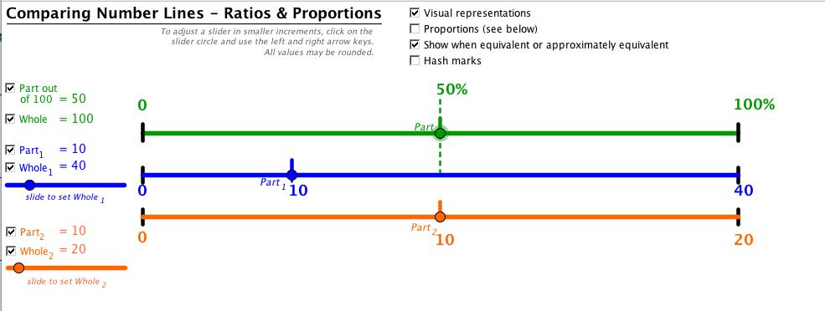

Notice the three number lines.

- The first line (green) represents the whole. 50% of the whole 100% is shown by the dotted line.

- The second line (blue) represents the ratio 10 out of 40.

- The third line (orange) represents the ratio 10 of 20.

Step 2: Explore the Applet
Do: | What Happens?
Check and uncheck the Part out of 100 and Whole checkboxes  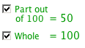 | Explain what happens on the green number line. Where is the part located? Where is the whole located?
Check and uncheck the Part₁ and Whole₁ checkboxes  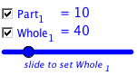 | Explain what happens on the blue number line. Where is the part located? Where is the whole located?
Check and uncheck the Part₂ and Whole₂ checkboxes  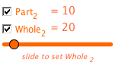 | Explain what happens on the orange number line. Where is the part located? Where is the whole located?

Step 2: Explore the Applet (cont)
Do: | What Happens?
Check the hash marks checkbox  Check the Show intervals checkbox 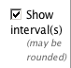  Move the slider | Explain what happens to the number lines. What do the numbers to the right of the number lines represent?
Check the proportions checkbox  Check the ratio checkboxes below | Notice the ratios.  Click on the green dot and move it. What happens to the ratios?  Click on the blue dot and move it. What happens to the ratios?  Click on the orange dot and move it. What happens to the ratio?
Check the show decimals checkbox  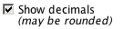 | Explain what happens as you move any of the sliders.
Click and drag the dot on the blue slider below the Whole₁ | What happens to the ratios?
Click and drag the dot on the orange slider below the Whole₁ | What happens to the ratios?

Step 3: Set up the following proportion:
a) First, uncheck the top part and whole. (Next to the green number line.)
b) Next, click on blue dot below the Whole₁ and adjust it to 5. (Note-if you click on the dot on the slider, you can adjust the size with more precision with the right and left arrows.)
b) Then, adjust the Part₁ to be 3 by clicking on the blue dot and dragging until the value is 3
c) Next, click the orange dot below Whole₂ and adjust it to be 15.
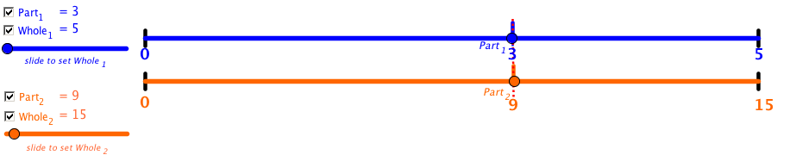

d) Then, click on the checkbox to show the Part₂ to be lining up with the blue Part₁.
(The red line shows up when the two ratios are equivalent and make a true proportion.)

e) The problem can then be shown by the double number line representation below:
0
5
3
9
15
0
3 out of 5 is the same as 9 out of 15.

We know they are equivalent when the number line on the top lines up with the number line below.
f.) You can also make equal sized intervals on the top and bottom number line to help predict whether the two ratios are proportional.

- In the example above, I can divide the line in 5 equal parts then use that information to place the 3 and the 9 on the number line.
- 5 divided in 5 equal parts means each line represents 1, so I go over to the third line and write 3.
- 15 divided by 5 equal parts means each line represents 3, so I count 3, 6, 9 to go over to the third line and write 9.
- So, 3 out of 5 is the same proportion as 9 out of 15 since they line up at the same place on the number lines.

g) To do this on the applet, click in the Hash marks checkbox then drag the slider to the right until you get to 5 intervals.
0
5
3
9
15
0

h) Check the intervals checkbox to see the amount each interval line increases by.
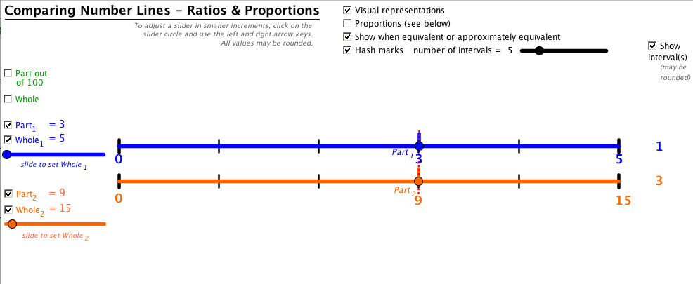

- To see the proportions set up, check the Proportions checkbox.
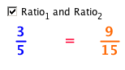
- Then check the Ratio and Proportion checkbox

Part I. Set these up
Set up the ratio shown. Explain if it is proportional or not.
Ratio | Set Up | Proportional?
 | 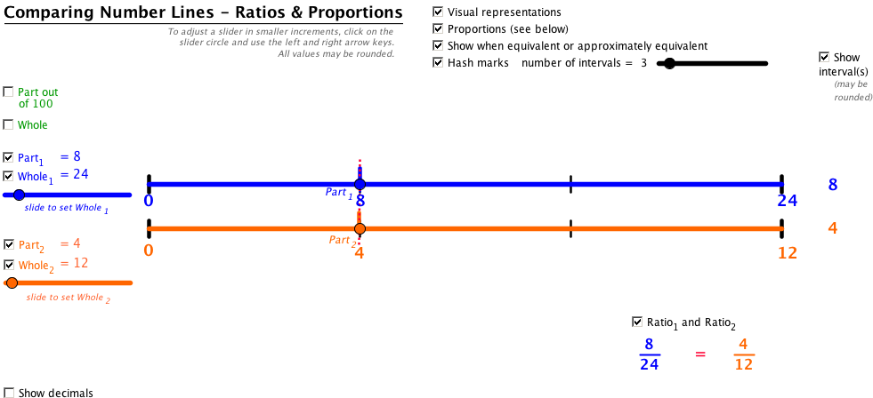
 | 

