Exploration: Distributive Property Matrix Multiplication (4)
(x + y) and x + y

Step 1: What does if mean for (x + y) to be squared? Explain your reasoning.

Step 2: Predict whether (x + y) is equivalent to x + y. Explain your reasoning.

Step 3: Launch the Distributive Property Matrix Multiplication (4) applet on the Wiki page. Use the check boxes to Show factored form.

Change the slider values so you have 1x and 1y in both sets of parenthesis.

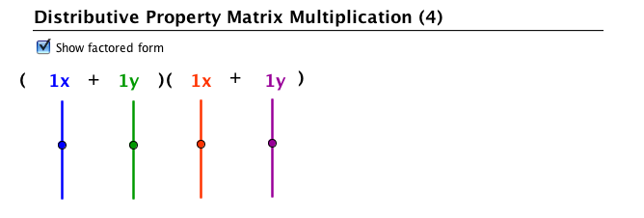
Use the check boxes to Show matrix and to Show matrix starting values. Then use the check box to Show products.

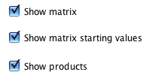
Draw the representations in this space:

What does each box represent? How do you know? Explain your reasoning.

Explain anything that you notice about the values in the boxes.

Step 4: Use the check box to Show solution.
Draw the representations in the space below:

Explain what you notice about the solution. How did the solution come about?

Step 5: Predict the solution to (2x + 5y). Explain your reasoning.

Step 6: Use the check boxes to hide everything except for Show factored form. Change the slider values to 2x and 5y for both sets of parenthesis.

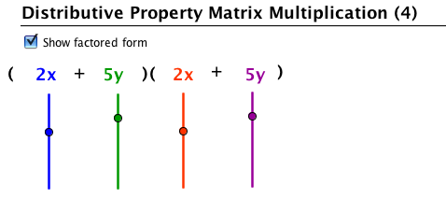
Use the check boxes to Show matrix and to Show matrix starting values. Then use the check box to Show product.

How does your prediction in Step 5 compare to the solution?

Explain whether or not you now think (x + y) is equivalent to x + y or not and justify your reasoning using information from your experience with the distributive property matrix multiplication applet.

Step 7: Predict what expression (x – y) will be equivalent to. Explain your reasoning. You may use drawings as well as words to represent your thinking.

Step 8: Use the applet to check your solution. If your solution was not correct, what part(s) of the expression did you get incorrect? Explain the difference between your reasoning and the solution itself.

Step 9: Predict what expression (4x –6y) will be equivalent to. Explain your reasoning. You may use drawings as well as words to represent your thinking.

