Exploration: Power to a Power Rule

Introduction

In this exploration you will use the Power of a Power Rule applet to explore power properties of exponents.

Step 1: Launch the Power of a Power applet
- Check the Colors checkbox to make each part of the term a different color.
- Move the sliders up and down and observe what happens to the coefficient and terms.
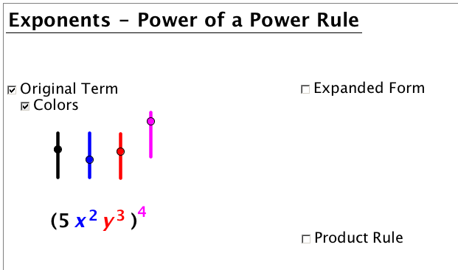
Step 2: Move the sliders to set up the problem provided.
- Move the black slider until the number at the front of the term (the coefficient) disappears
- Move the red slider until the variable y disappears
- Move the blue slider until the exponent associated with x is equal to 2
- Move the pink slider until the exponent outside the parentheses is equal to 4

Step 3: Check the Expanded Form checkbox to see the term multiplied out.
- Notice how many times the term inside the parentheses is repeated.
How does the number of times repeated relate to the exponent outside the parentheses?

Step 4: Check the Product Rule checkbox to see how the expanded form can be simplified.

Step 5: Fill in the table for example provided.

Example:

Original Expression | Expanded Form | Power to a Power Rule with Solution

Directions: Set up each problem in the applet. Fill in the table. Answer the associated questions.
Problem 1.
Original Expression | Expanded Form | Power to a Power Rule with Solution

1a. In the Expanded Form, how does the number of times repeated relate to the exponent outside the parentheses?
1b. When you raise a power to power what operation do you perform on the exponents?

Problem 2.
Original Expression | Expanded Form | Power to a Power Rule with Solution

2a. In the Expanded Form, how does the number of times repeated relate to the exponent outside the parentheses?
2b. Explain what you do with the exponents when you have more than one variable?

Problem 3.
Original Expression | Expanded Form | Power to a Power Rule with Solution

3a. In the Original Expression, what is the value of the exponent related to x? __________
3b. In the Expanded Form, how many times is the x repeated? ___________

3c. In the Solution, what is the value of the exponent related to x? ________
What values are multiplied to get that value? Why?

Problem 4.
Original Expression | Expanded Form | Power to a Power Rule with Solution

4a. What do you do to the coefficient when using the power to a power rule?

Problem 5. Expand your thinking
Note: This problem can not be set up in the Power to a Power applet but you can use what you know about the division rule to help simplify then you can solve the problem.

Original Expression | Apply Division Rule | Expanded Form | Power to a Power Rule with Solution
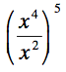

5a. Explain how you solve the problem when you have multiple operations with exponents happening in one problem.

Conclusion:
- State the power to a power rule in your own words.
- Give an example of the power to a power rule.

