Getting Started:
In your browser, go to the Algebraic Expressions – Number Line Model for Multiplication applet.
- Check the Expression checkbox to see the expression.
- Move the slider next to the Expression checkbox to see a coefficient multiplied by a variable..
- Move the Variable slider to change the variable name.
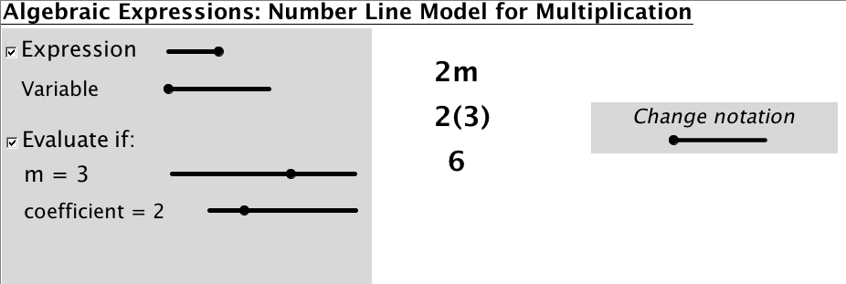

Part I.
Explore the Number Line Model for Multiplication
- Check the Model checkbox to see the expression represented on a number line.
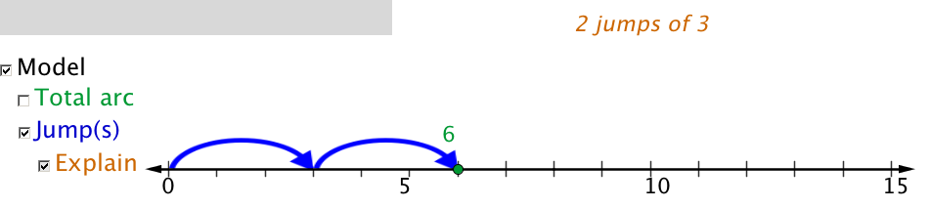
- Check the Explain checkbox to see an explanation of the model with the value and coefficient selected.
The example above represents the expression 2m when the variable m = 3 and the
coefficient is 2.

Part II.
Predict what the number line model will look like with the following values for m and the coefficient:
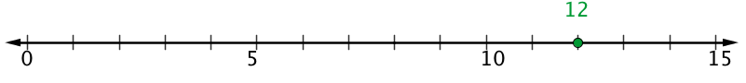
a) coefficient = 4 and m=3 4(3)

b) coefficient = 4 and m=5 4(5)
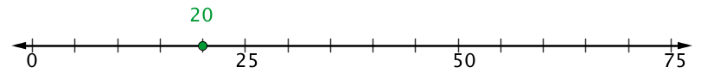

c) coefficient = 5 and m= -3 5(-3)

Part III.
Give the expression for the model provided

1. _____________
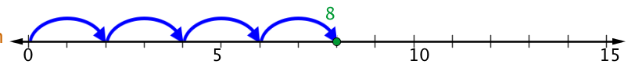
2. _____________

