Applet Overview:
Algebraic Expressions - Number Line Model for Multiplication

Essential Math Concept
- Understanding, evaluating, and representing algebraic expressions on visual models.

Essential Questions To Consider
- Can students represent an algebraic expression that includes multiplication on a number line model?
- Can students predict changes in the model as the value of the variables in an expression changes?

Student Engagement
Step 1: The Algebraic Expressions – Number Line Model for Multiplication applet provides examples of expressions with various variable names. The tool is also designed to evaluate the given expression with a number of different quantities. Expressions can also be shown in a variety of notations.

- Check the Expression checkbox to see the expression.
- Move the slider next to the Expression checkbox to see a coefficient multiplied by a variable..
- Move the Variable slider to change the variable name.
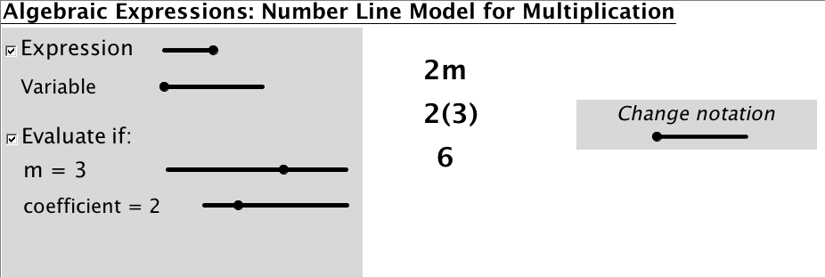

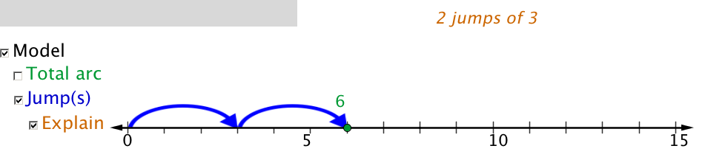
Step 2: Check the Model checkbox to see the expression represented on a number line.
Check the Explain checkbox to see an explanation of the model with the value and coefficient selected.

