Exploration: Graphing Inequalities 3

Part I. Introduction

In this exploration you will solve inequalities by multiplication and division.
- If each side of a true inequality is multiplied or divided by the same positive number, the resulting inequality is also true.
- If each side of a true inequality is multiplied or divided by the same negative number, the direction of the inequality symbol must be reversed so that the resulting inequality will also be true.

Directions:

Step 1: Launch the Inequalities on the Number Line - 0 applet using Firefox.
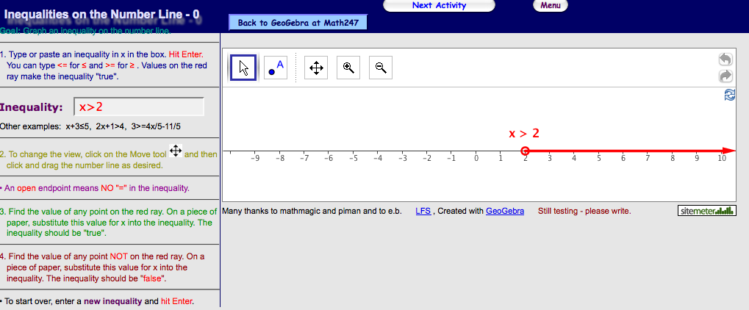

- Notice the inequality input box.

- Enter an inequality and hit the enter/return key
- The equation will be graphed

Step 2: Solve the given inequality then graph.
Step 3: Check your solution and graph using the applet
Example 1: Solve ½ x ≥ 2
Multiply both sides by 2 2 (½ x) ≥ 2(2)
x ≥ 4

a) Enter the inequality into the applet to check

b) The result looks like the graph below:
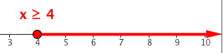
Example 2:
Solve -x ≤ 3
Multiply each side by -1 - 1(-x) ≤ -1( 3 )
Switch signs, Change ≤ to ≥ x ≥ - 3
Graph then check in the applet
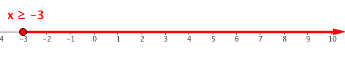
Example 3: Solve 3x ≤ 12
Divide both sides by 3 (3 x)÷ 3 ≤ 12 ÷3
x ≤ 4
a) Enter the inequality into the applet to check
b) The result looks like the graph below: 
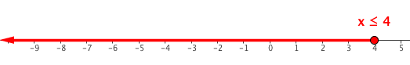
Example 4:
Solve -2x > 8
Divide each side by -2 -2x ÷ -2 > 8 ÷ -2
Switch signs, Change ≤ to ≥ x < - 4
Graph then check in the applet
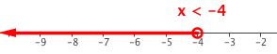

Part II: Solve, Graph, & Check
Solve the inequality provided. Predict the graph. Draw the graph of your prediction on the number line provided. Check your answer by entering the inequality in the entry box and hitting return. Compare the result to your prediction.
Solve the Inequality | Graph the Solution
1) 1/5 x ≤ 1
2) -x > 8
3) 1/3 x ≥ -1
4) - ½ x ≤ -2

Solve the Inequality | Graph the Solution
5) 4x > 8
6) -3x ≥ -6
7) 2 < -x
8) 5x < 3x - 8
9) 6x -2 ≥ 4x + 1
10) 8 + 2x < 12

