Exploration: Walking the Number Line

- Explore the slider and check box functions in the Walking the Number Line (2) applet.
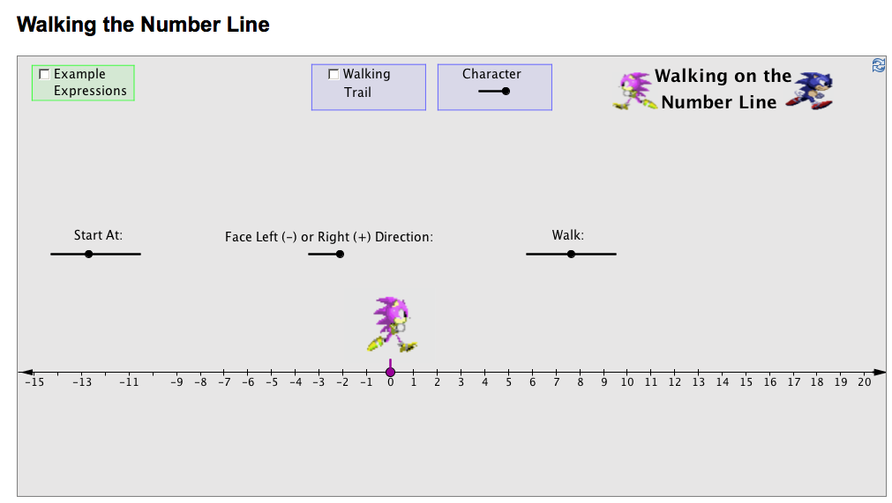

  - Check the Example Expression box to locate different expressions. Use the slider to change the expressions.
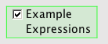
  - Check Walking Trail to see the path that is taken by your character.

  - Choose one of two characters by changing the slider.
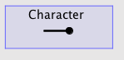
  - Leave Hints and Solution unchecked for now.

  - Move the slider to the first number in the expression under Start At.

  - Move the slider to Face Left (-) or Right (+) Direction.


  - Move the slider to Walk either direction, forward for a positive number and backwards for a negative number.

  - The arrows that you see represent the path that your character takes with your directions.

  - Check Solution to see the solution of the walking trail as well as the work and final answer.
  - Check Hints to get help if it is needed to solve the problem. Checking the first box will tell you where to start. Checking the second box will tell you which direction to face. Checking the third and final box will tell you how many times to walk and in which direction.

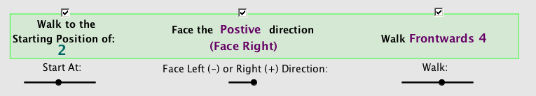

For example, the first expression is 2 + 4.

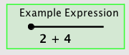

The character starts at 2, stays facing right since there is a + , and walks forward 4 times for the second integer. After checking the boxes mentioned above, the example looks like the following:
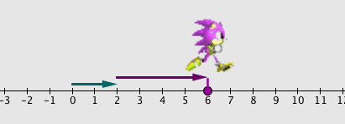

When the solution is checked, the following is what is seen:
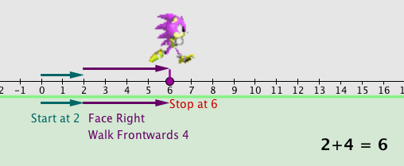

2. Work through the following steps for solving each expression in the chart.

a) Give your prediction of the result of the addition problem after “walking the number line”
b) Use the applet to model the operation
c) Compare the results with your prediction.
d) Explain how the model justifies the correct solution to the expression


Note: Before beginning a new expression, always reset the tool by clicking the refresh button in the upper right hand corner of the applet.

Expression | Predicted Result | Model Explanation/Justification
- 5 + 7
4 + (- 3)
- 5 + 3
- 4 + 1
-1 + - 4

- What did you notice about the results for -5 + 7 and 4 + (-3)? Explain your observations and why you think as you do.

- Predict what the results will be for the following addition problems.

  - 15 + (-6) b. 18 + (-12)

- -13 + 8 d. -16 + 10

- Explain what you noticed about the results of the four expressions. Why did this occur?

- What did you notice about the results for -5 + 3 and -4 + 1? Explain your observations and why you think as you do.

- Predict what the results will be for the following addition problems.

  - -20 + 13 b. -19 + 9

- 10 + (-22) d. 12 + (-30)

e. Explain what you noticed about the results of the four expressions. Why did this occur?

- What did you notice about the result for -1 + (-4)? Explain your observations and why you think as you do.

- Predict the results of the following addition problems.

  - -12 + (-11) b. -19 + (-9)

- -8 + (-22)

- Explain what you noticed about the results of the three expressions. Why did this occur?

Please STOP when you get to this point to discuss the results as a whole class. You may go back and review your work up to this point.

Note: Remember to always reset the tool before beginning a new expression by clicking the refresh button.

9. Work through the following steps for solving each expression in the chart.

a) Give your prediction of the result of the subtraction problem after “walking the number line”
b) Use the applet to model the operation
c) Compare the results with your prediction.
d) Explain how the model justifies the correct solution to the expression

Expression | Predicted Result | Model Explanation/Justification
-2 – (-5)
-5 – (-3)
-4 – (-1)
-1 – 4

10. What do you notice about the results for these four expressions? What “operation” gave you the result that was needed? Was it the same for all four? Why or why not?

11. Predict what the results will be for the following subtraction problems.

  - -11 – (-15) b.-20 – (-7)

c. -15 – 2 d. 17 – 20

- 22 – (-2)

- Explain anything that you noticed about these results.

Please STOP when you get to this point to discuss the results as a whole class. You may go back and review your work up to this point.

12. Without using the applet to model the addition or subtraction, predict whether the results of each expression will be positive or negative.

Expression | Check one: | Explanation:
5 – (-2) | 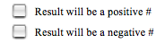
-5 – (-2)
-2 + 4
-2 - 4

13. Without using the applet to model the addition or subtraction, compare the two expressions and check the correct response

Expression 1 | Check one: | Expression 2
-4 – (-3) | 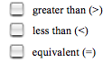 | -4 + (-3)
Explain Choice:

5 – (-2) |  | 5 + ( -2)
Explain Choice:

-2 – (-4) |  | -2 + 4
Explain Choice:

