Applet Overviews: Order of Operations (1 - 6)

Overview:
The following applets are designed to help students understand the meaning and effects of the order of operations in order to manipulate and solve expressions.

The rules of this convention include the fact parentheses are evaluated first then exponents if they are present. Then multiplication and division are always done before addition and subtraction (given there are no parentheses or exponents involved.) Multiplication and division are at the same level and therefore are evaluated as they appear in an expression left to right. This is also true for addition and subtraction, being at the same level, they too are evaluated left to right after the other level operations are completed. Note: The fraction bar operates as a grouping symbol like parentheses so the numerator and denominator are each evaluated before dividing. The order for evaluating is parentheses then exponents, then multiplication and division (first left to right) then addition and subtraction (first left to right).
Step 1. Evaluate expressions inside parentheses
Step 2. Evaluate all exponents
Step 3. Do multiplication or division, whichever comes first left to right
Step 3. Do addition or subtraction, whichever comes first left to right

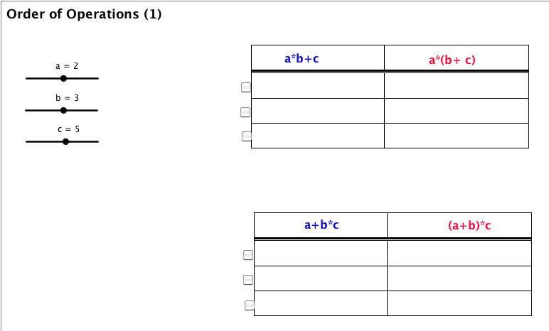
It is very important that students explore how these operations work before being provided shortcuts to remember the order. They should have multiple opportunities to predict and check solutions. Shortcuts such as PEMDAS are discouraged before students have the understanding to associate it to in an expression.

Order of Operations (1)
First applet helps students see that when there is multiplication and addition, multiplication comes before addition unless there are parentheses.

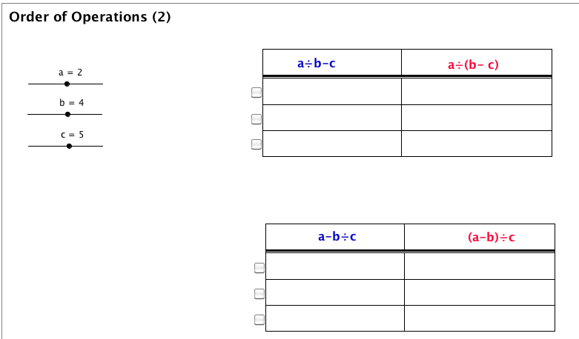

Order of Operations (2)
This applet helps students see that when you have division and subtraction, division comes before subtraction unless there are parentheses.

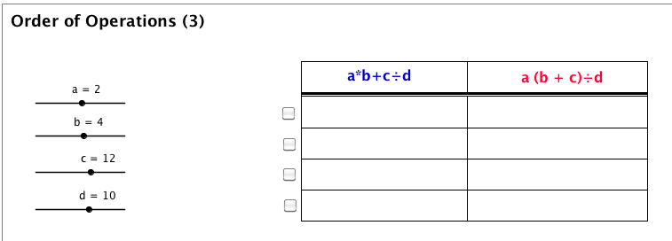
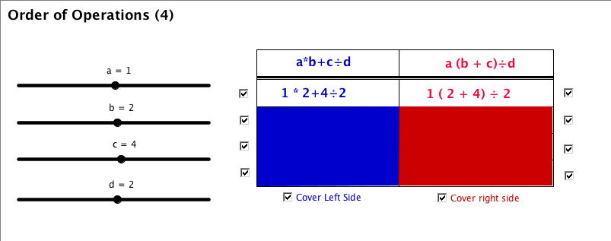

Order of Operations (3 & 4)
This applet helps students see that when you have multiplication, addition, and division; multiplication & division come before addition unless there are parentheses. Version 4 has the ability to turn on and off visibility.

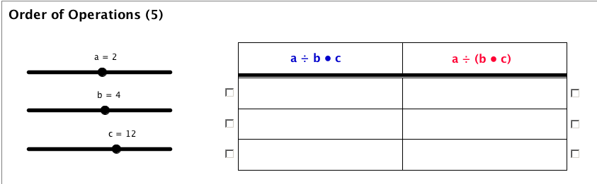

Order of Operations (5)
This applet helps students see that when you have multiplication and division; they are on the same level so do what comes first left to right

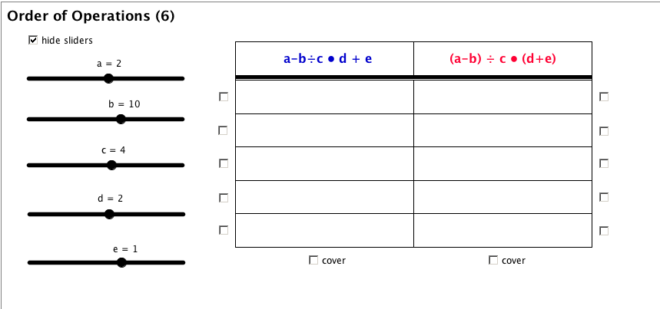

Order of Operations (6)
This applet combines addition, subtraction, multiplication and division in the same problem.

