Exploring Slope 2

Part I. Choose the slope of the line given on the graph. Explain your reasoning.
Top of Form
Example | Graph | Explain your reasoning
1. ______  The slope is:  - -2  - -1  - - ½  - ½  - 1  - 2 | 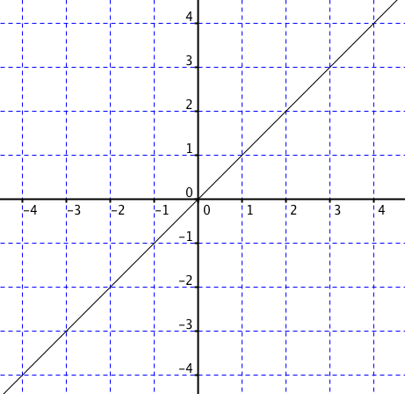
2. ______  The slope is:  - -2  - -1  - - ½  - ½  - 1  - 2 | 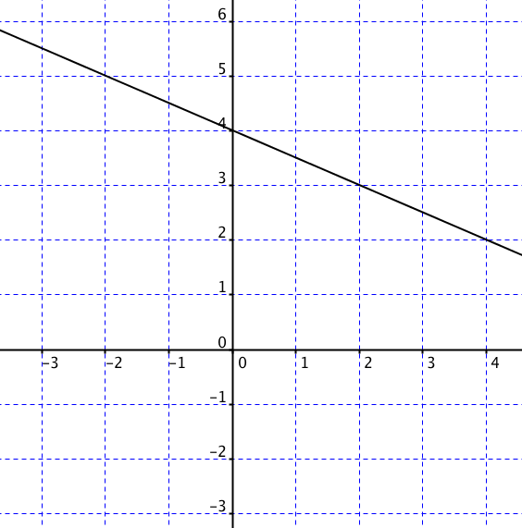
3. ________  The slope is:  - -2  - -1  - - ½  - ½  - 1  - 2 | 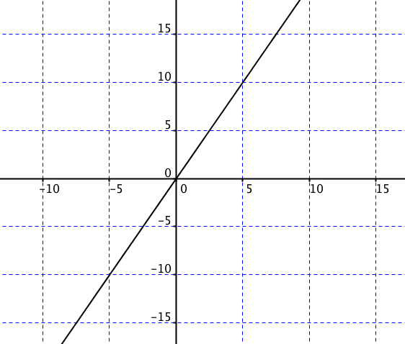
Example | Graph | Explain your reasoning
4. _______  The slope is:  - -1  - -½  - ½  - 1  - 2  - 3 | 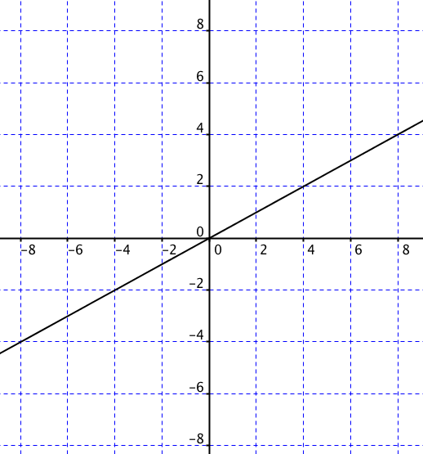
5. _______  The slope is:  - -1  - -½  - ½  - 1  - 2  - 3 | 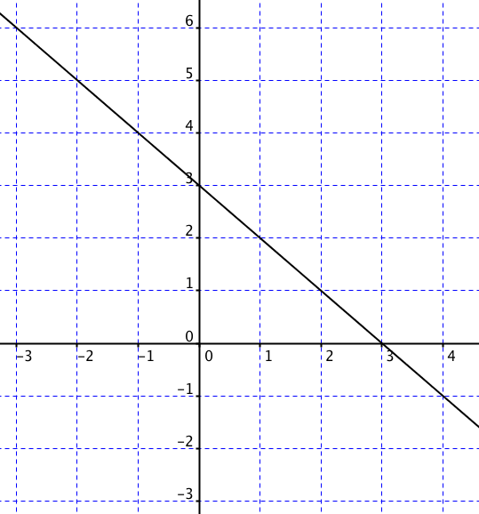
6. _______  The slope is:  - 1  - -½  - ½  - 1  - 2  - 3 | 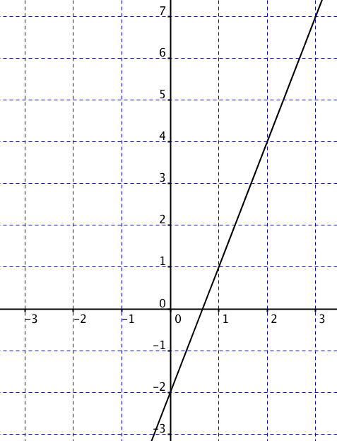
Part II. Determine the slope of the lines given two points A and B for each line. Determine which slope is greater then select the appropriate letter. Fill it in next to the example number.
Explain your reasoning using the graph and calculations.
- _____ | Slope of Line 1 | - Greater than (>)  - Equal to (=)  - Less than (<) | Slope of Line 2
Find the slope of Line 1 given points:  A = (0,1)  B = (3,4)  Find the slope of Line 2 given points:  A = (-1, 2)  B = (1, 4) | Explain your reasoning using words, calculations, and the graph:  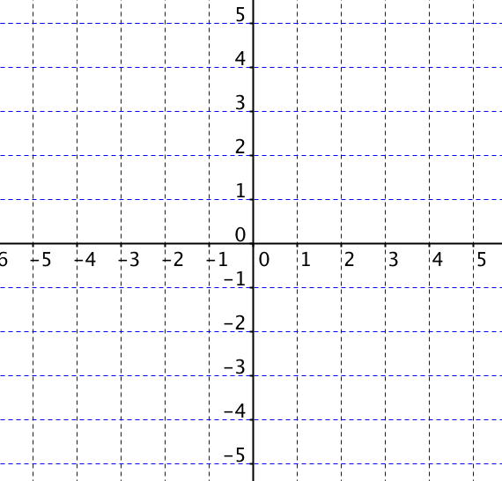
2. _____ | Slope of Line 1 | - Greater than (>)  - Equal to (=)  - Less than (<) | Slope of Line 2
Find the slope of Line 1 given points:  A = (-3, 2)  B = (2, -3)  Find the slope of Line 2 given points:  A = (-3, 2)  B = (1, 4) | Explain your reasoning using words, calculations, and the graph:
Bottom of Form

