Exploration: Locating Equivalent Fractions

This exploration incorporates the use of a number line to deepen understanding of fraction concepts. During the activity you will explore the location of fractions as well as their equivalent fractions.

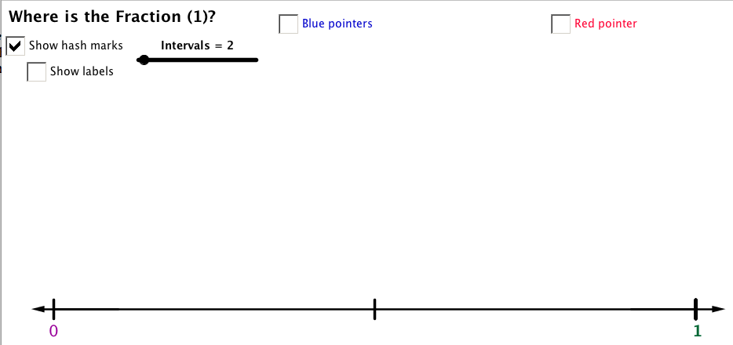
Getting Ready
Launch the “Where is the Fraction? (1)” applet. This applet shows a number line from 0 to 1. Notice the Show hash marks checkbox is checked and the Intervals slider is set to 2.
Part I.
- Slide the Intervals slider to 6.
- Click on Show labels on the applet to see the labels under the number line.
- Record the fractions below the appropriate hash mark on the number line below.
- Click the Simplify check box.
Record any additional fractions that describe the same locations.
Fraction | Equivalent Fraction  (Simplify/reduce to lowest terms) | What number was divided into both the numerator and the denominator to get the simplified fraction?

- Un-Click the Simplify check box then slide the Intervals slider to 10.
- Click on Show labels on the applet to see the labels under the number line.
- Record the fractions below the appropriate hash mark on the number line below.
- Click the Simplify check box.
Record any additional fractions that describe the same locations.
Fraction | Equivalent Fraction  (Simplify/reduce to lowest terms) | What number was divided into both the numerator and the denominator to get the simplified fraction?

- Un-Click the Simplify check box then slide the Intervals slider to 12.
- Click on Show labels on the applet to see the labels under the number line.
- Record the fractions below the appropriate hash mark on the number line below.
- Click the Simplify check box.
Record any additional fractions that describe the same locations.
Fraction | Equivalent Fraction  (Simplify/reduce to lowest terms) | What number was divided into both the numerator and the denominator to get the simplified fraction?

Part II.

- Given the following fractions, name at least one equivalent fraction.

Given fraction | Equivalent fraction(s)

- On the number line below, show the given fraction below its location and an equivalent fraction above it.

