**Seesaw Basic Features**

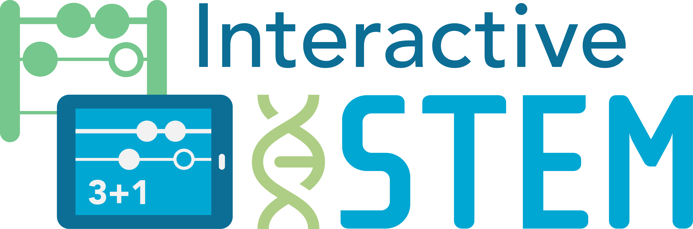

Interactive Technologies in STEM Teaching and Learning

***Early Mathematics and Technology Math Science Partnership***

You will use Seesaw to share screencasts as part of your participation in the project. You may create screencasts with Explain EverythingTM or within Seesaw using the "Drawing" feature.

Please note that the "Record" feature is only when using a mobile device app and it is NOT currently available when you use a computer browser.

**Part I – Basic Navigation in a Seesaw Class**

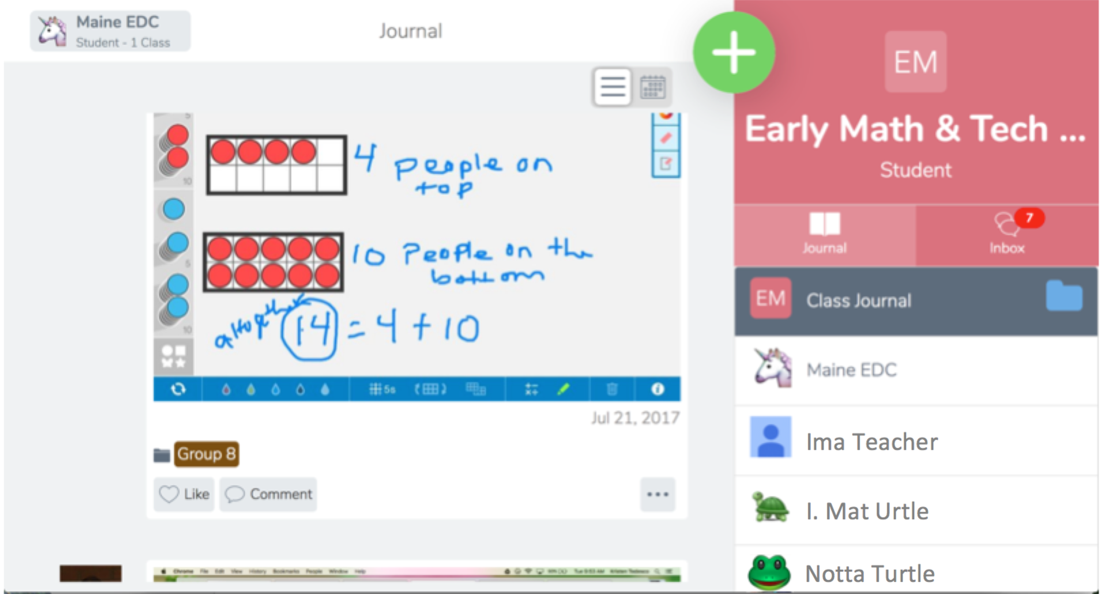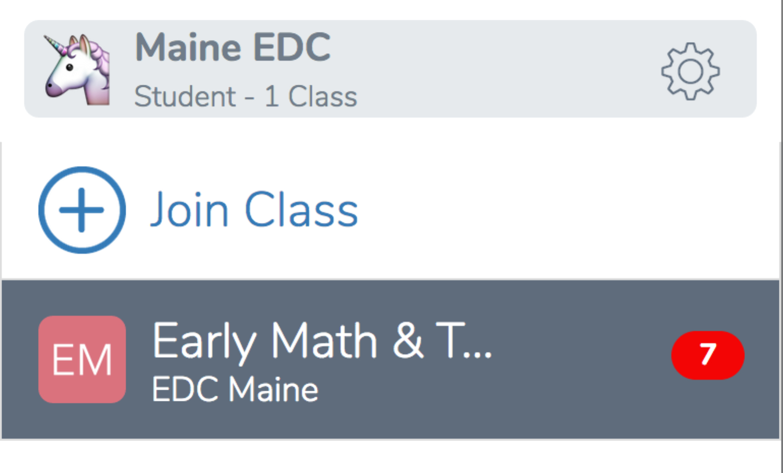

Select the **folder** icon to view a specific folder, such as for your Cohort

Select to view your **journal**

Select the **+** to add an item such as a drawing or note

Select a **name** to see just their items

Select the **3 dots** to see your **item** **menu**, which allows you to delete, edit, assign to folders or people, etc.

Scroll through the **shared items** in the class feed or a folder

Select the **speech bubble** icon to leave a comment

Select the **heart** icon to "like" an item

Select the **folder** icon to add or remove your item from one specific folder

The **gear icon** access to the account settings, device information, and the way to sign out.

Select **your name** to see the navigation sidebar.

This document is created by Education Development Center, Inc. Copyright 2017. Funded by a Maine Mathematics and Science Partnership Project (RFP# 201610203). Opinions expressed in this brief are those of the contributors and not necessarily those of the Maine Department of Education. Learn more at [interactiveSTEM.org](http://interactivestem.org/).



**Part II – Adding a Drawing or Screencast using the Seesaw Drawing Feature**

1. 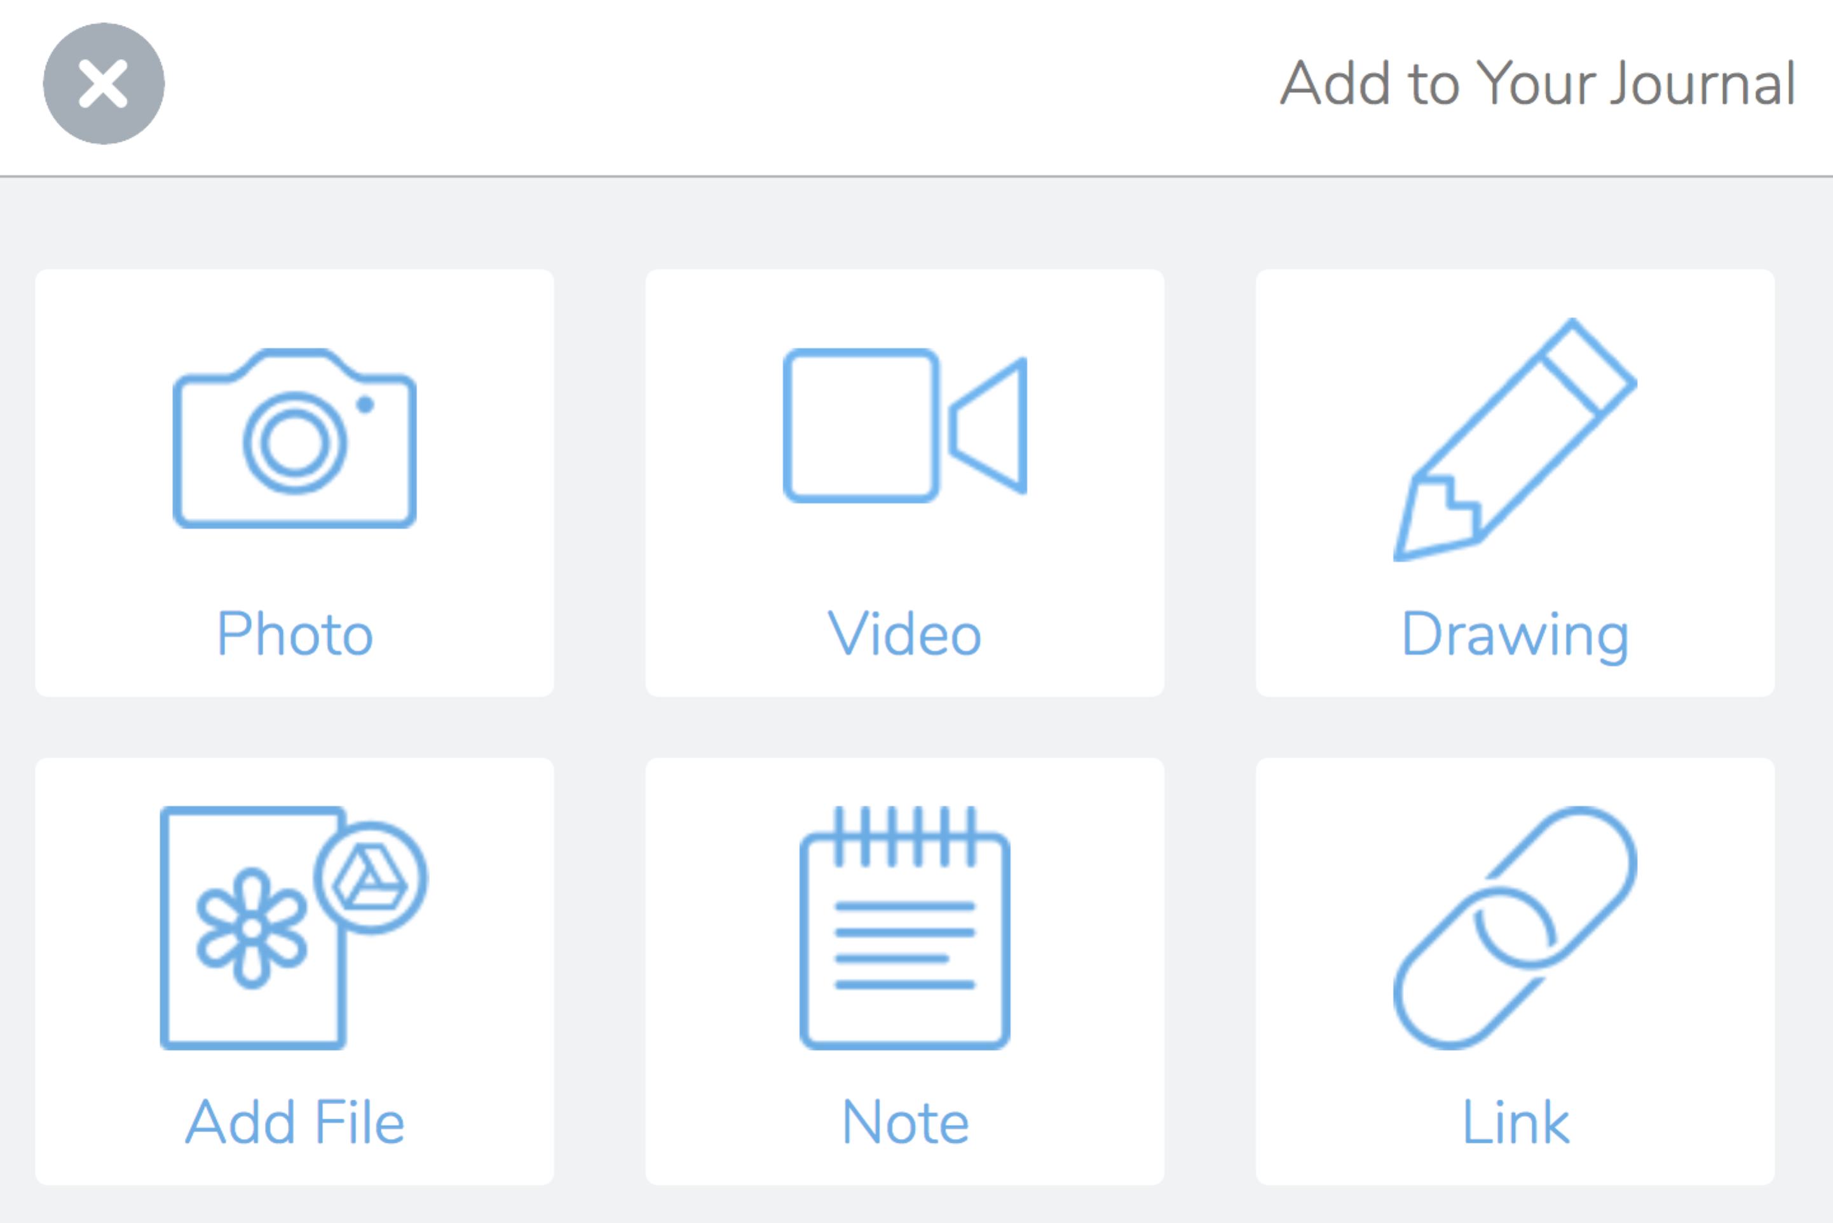Select the Plus sign (Macintosh HD:Users:ptierney-fife:Desktop:Screen Shot 2017-03-15 at 10.18.16.png) in the upper right
2. Select the Drawing option
3. Start drawing with the pen tool, or use the controls on the bottom bar to erase drawings, type text, change the pen and text color, change the pen width, or record (mobile device only).

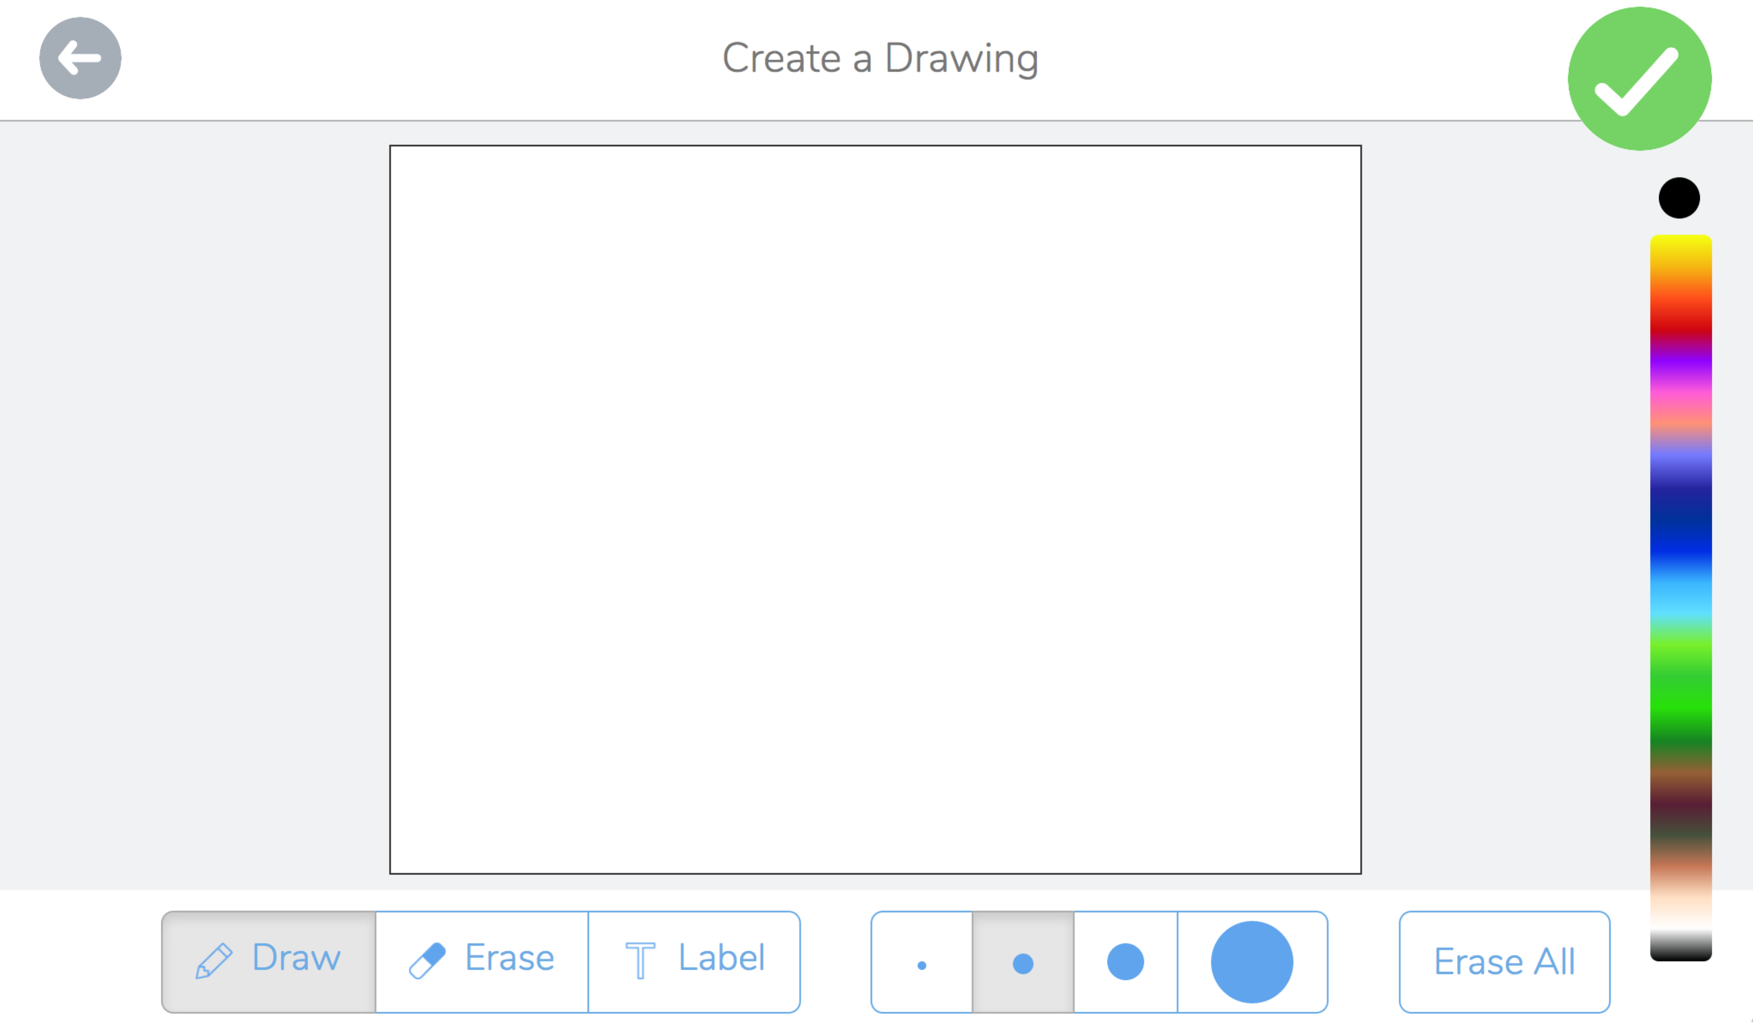

Select a **color** before using the pen or typing text

Select the **Erase all** button to erase all drawings *(to delete text, select T and click on the text and click delete)*

Select the **circles** to change the pen width

Select the **arrow** to go back (delete the drawing)

Select the **Erase** toolto erase drawings with the pen *(not typed text)*

Select the **Draw** tool to draw

Click the **Label** tool to type, modify, and delete text

On a mobile device you can select **Rec** to start recording audio ***and*** actions on the screen *(this is not currently available on a computer)*

**Please note:**

1. **you can NOT record audio while using a computer** in the current version
2. **you can NOT record audio while typing text** in the current version
3. you can record audio while you draw with the pen tool or erase with the eraser
4. you can draw and type without recording audio
5. you can draw and type first, click the checkmark in the upper right, and then record audio
6. you can record, pause the recording, and record more (it will play back-to-back)
7. 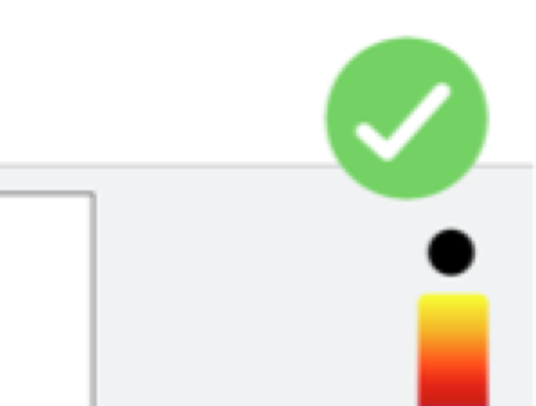When you are done, select the checkmark in the green circle in the upper right
8. Review your drawing/recording
9. You can edit your drawing using the tools on the bottom of the screen; if you made a recording the screen and options will be slightly different (see second image below)

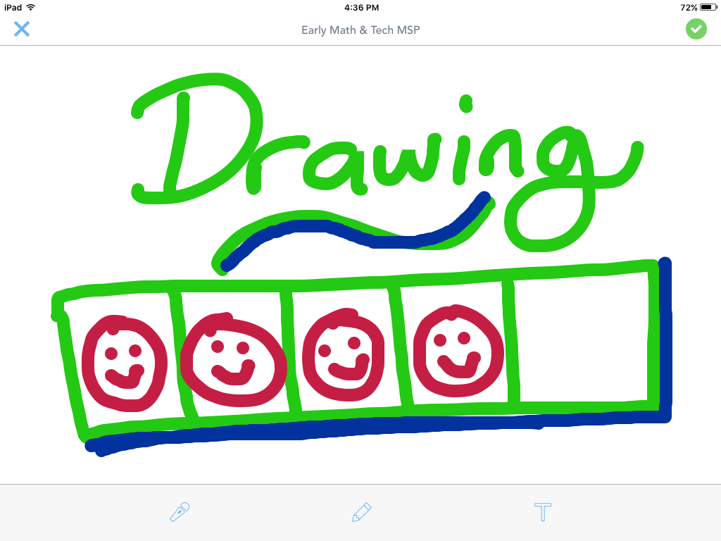

Select theRecord tool (microphone) to start recording audio (only); you can pause and continue recording, but you cannot draw or type text; click the **checkmark** in the upper right when done recording

Select the **Label** toolto add text (which brings you back to the drawing screen)

Select the **Draw** tool to return to the drawing screen

Select the **X** to delete the drawing

1. If you made a recording for your drawing, your review screen will include a play button and an audio time bar, and the icons in the bottom bar will have different effects (see notes below)

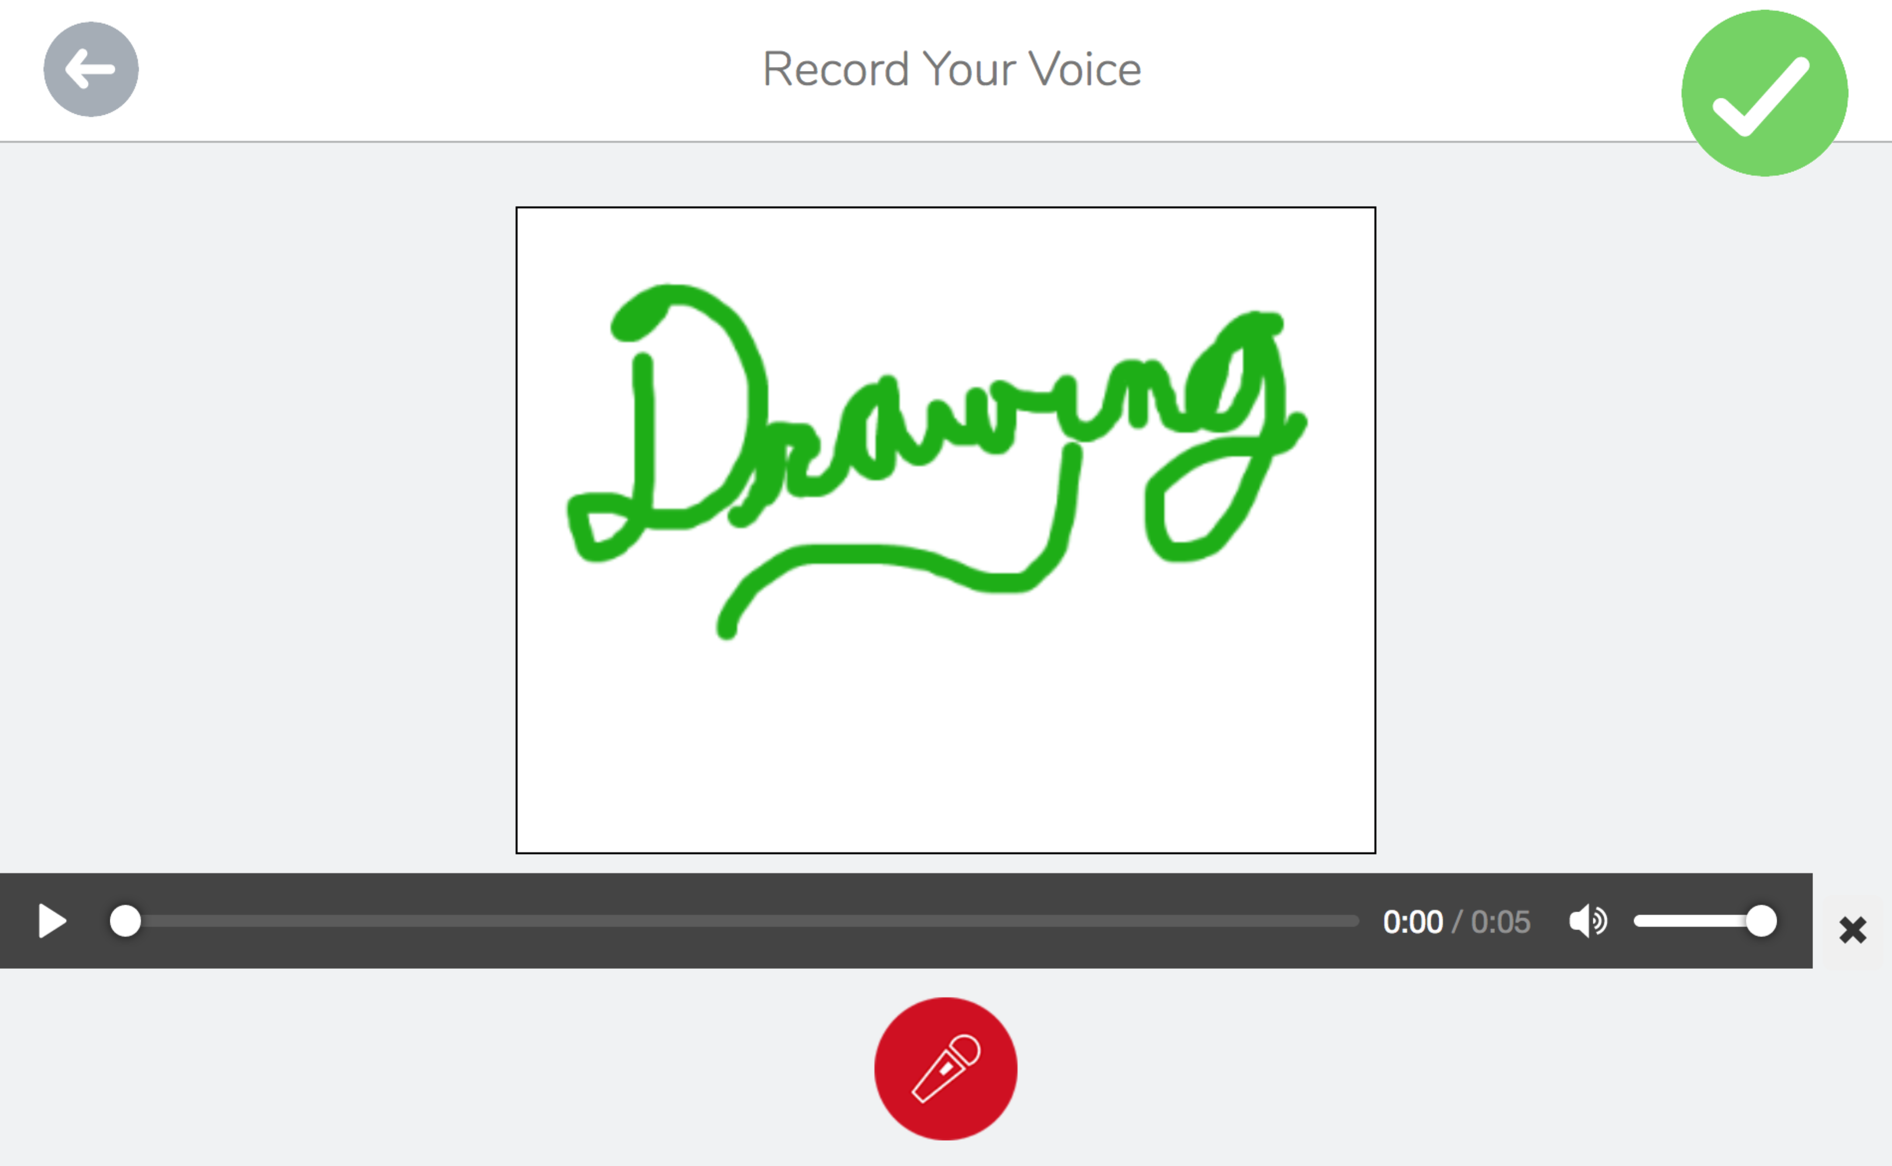

Select the **microphone** to **continue** the recording (adds new audio after the previous audio)

Select the **X** to delete the recording

Select the **arrow** to delete the recording

Click the **triangle** to play the recording

1. When you are done, select the check mark in the green circle in the upper right
2. Continue optional editing as needed using the audio bar and the tools near the bottom, then select the check mark in the upper right
3. 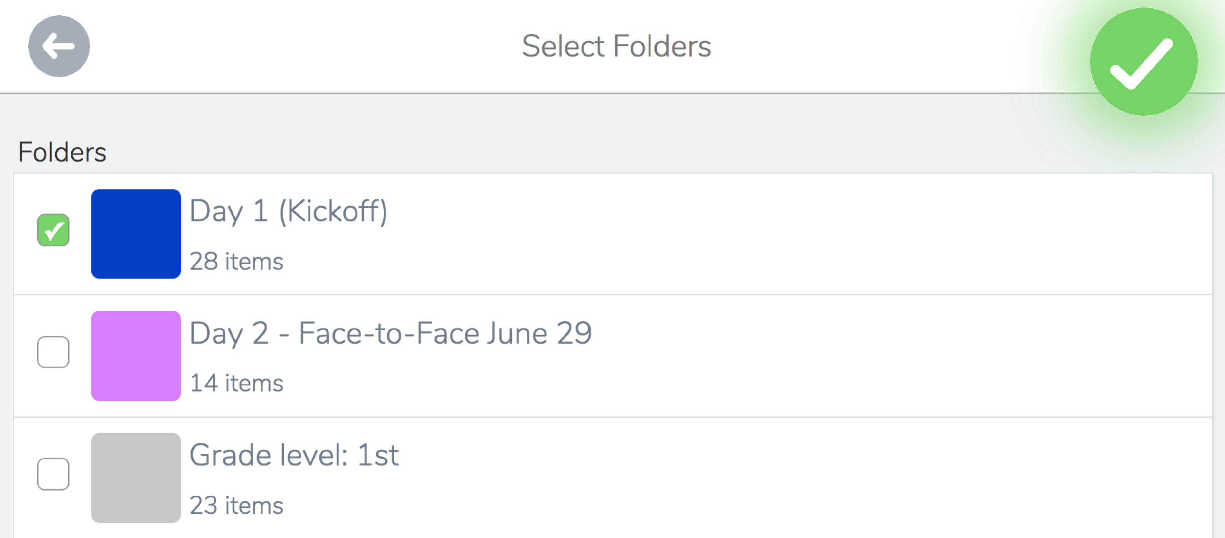You may be prompted to select one or more folders in which to put the item; select the folders you want (if any) and select the checkmark in the green circle
4. See your item in the class feed and in any folders you selected; depending on the class settings, it is possible it will not appear for others to see until it is approved by teachers/facilitators (items waiting approval will have a blue bar at the top that reads, "WAITING FOR APPROVAL")
5. 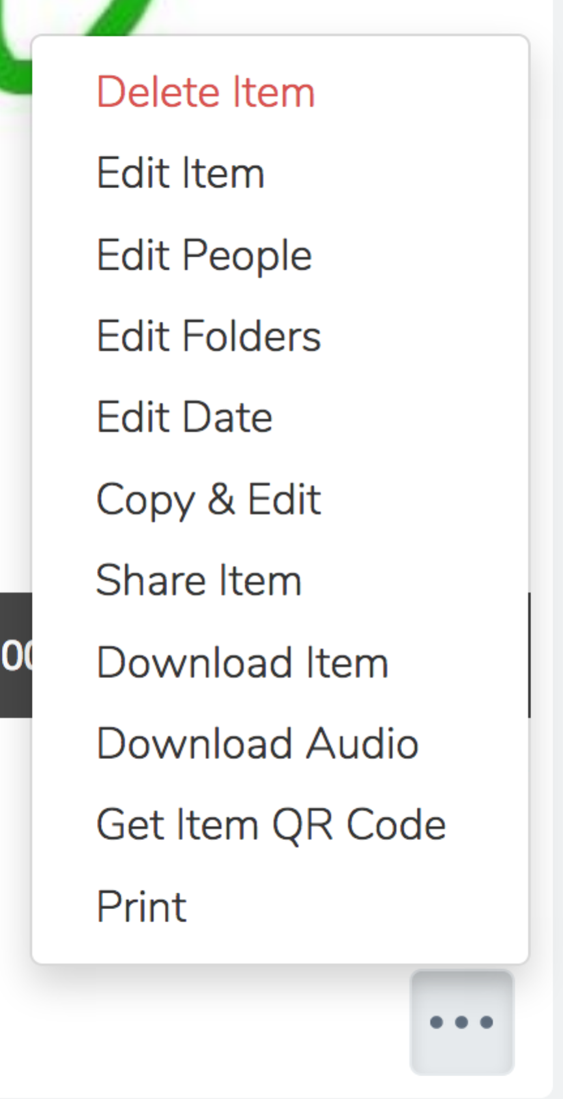You can delete, copy, edit, and change the people and the folder(s) for the item using the menu (click the 3 dots) and icons under the item; see also the image describing basic navigation features on page 1 of this handout

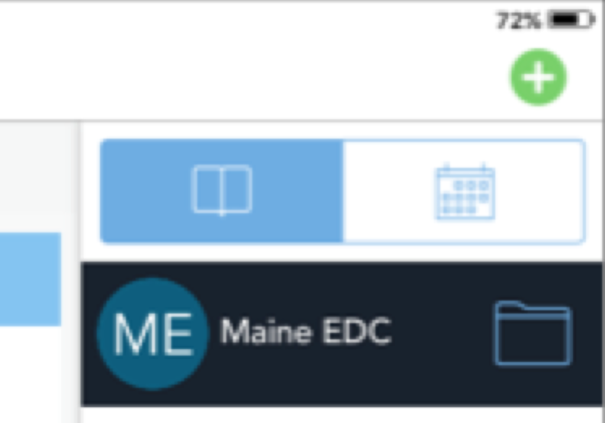**Part III – Adding a Screencast Saved on a Mobile Device**

*(please note this information may not be up to date)*

1. 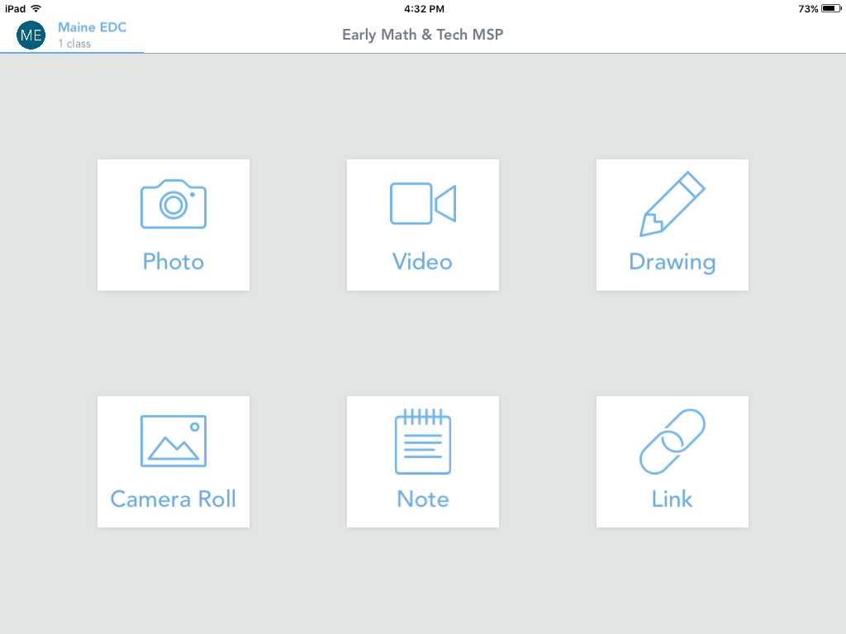Select the Plus sign (Macintosh HD:Users:ptierney-fife:Desktop:Screen Shot 2017-03-15 at 10.18.16.png) in the upper right
2. Select the Camera Roll option (may be different on your device)
3. 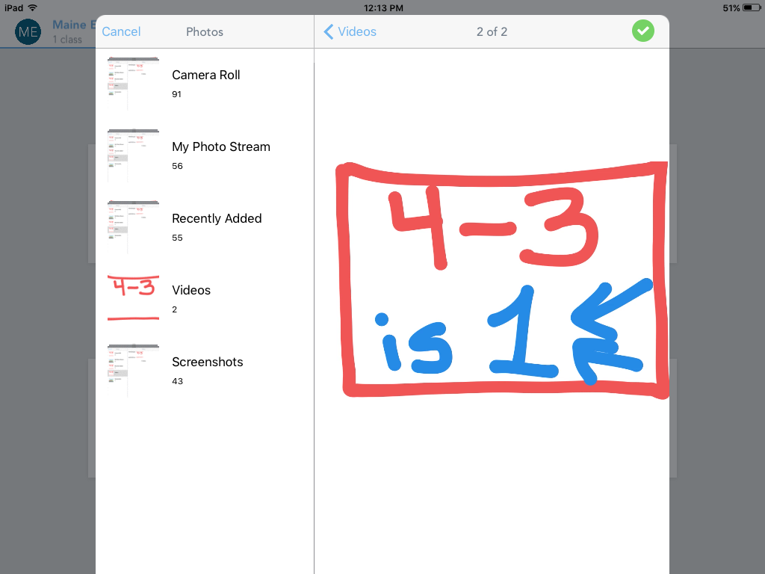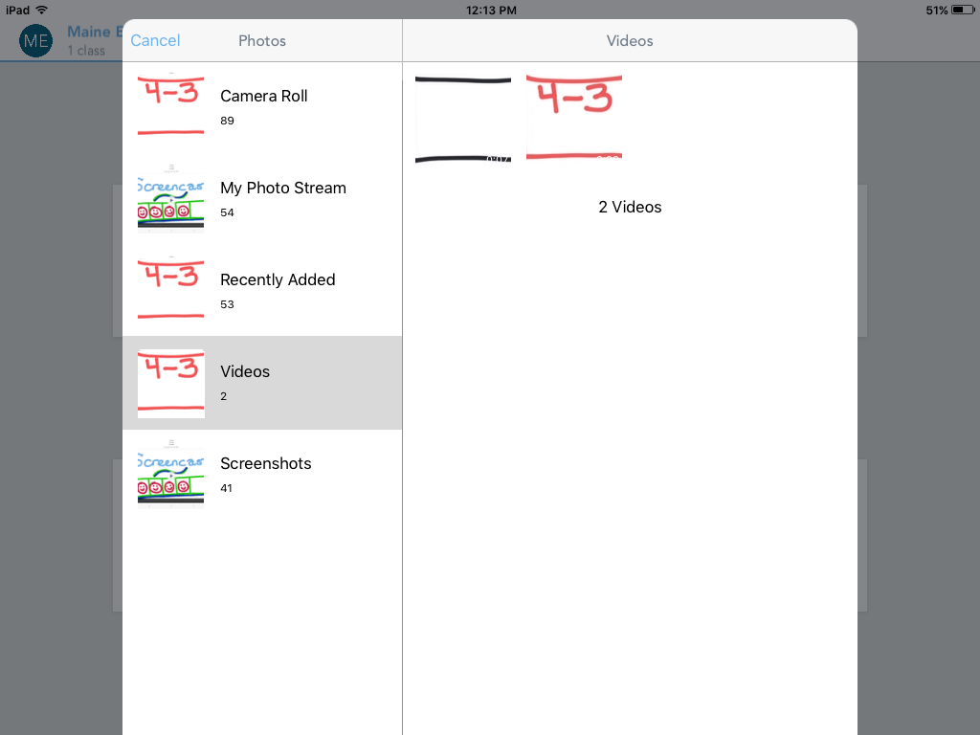Select the videos folder, then select your video
4. Select the checkmark in the green circle
5. 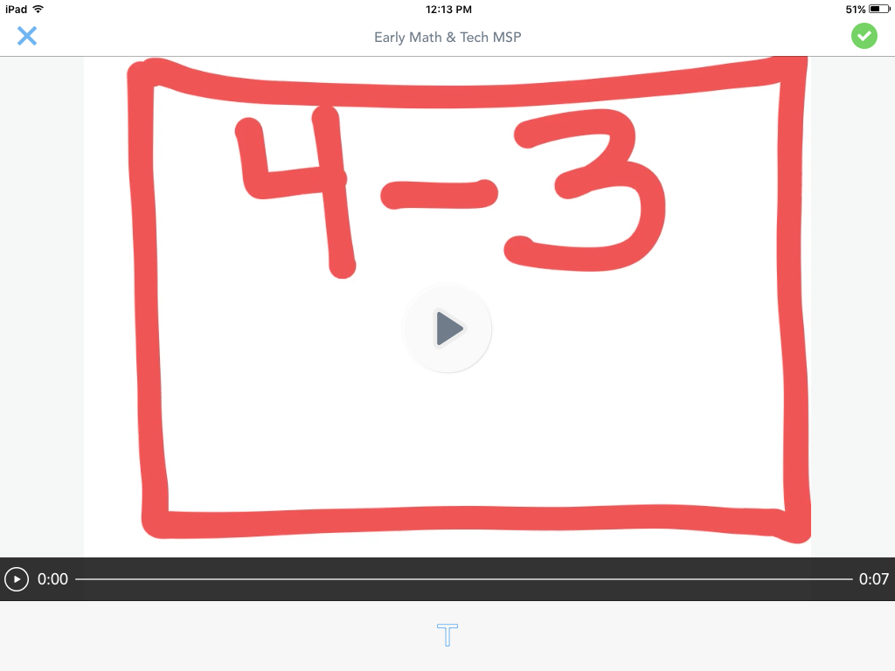Review your video; if you want to add a caption, select the T at the bottom
6. Select the checkmark in the green circle
7. 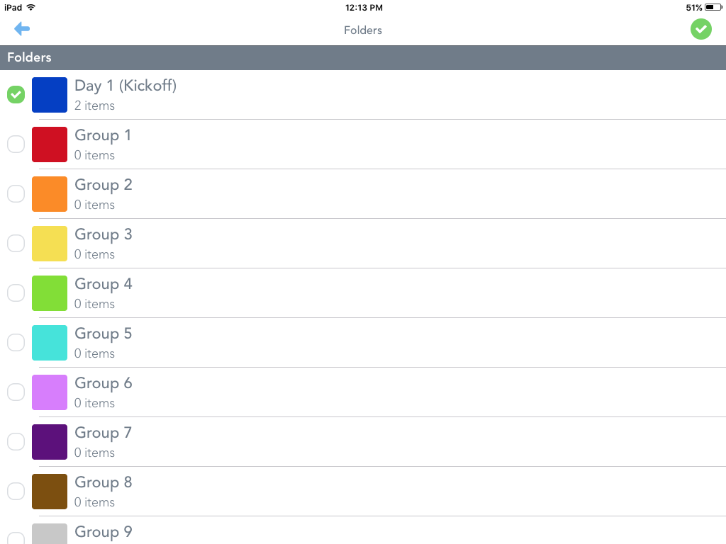You may be prompted to select one or more folders in which to put the item; select the folders you want (if any) and select the checkmark in the green circle
8. See your item in the class feed and in any folders you selected; it will not appear for others to see until it is approved by teachers/facilitators (items waiting approval will have a blue bar at the top that reads, "WAITING FOR APPROVAL"), as shown in the image on page 1 of this handout

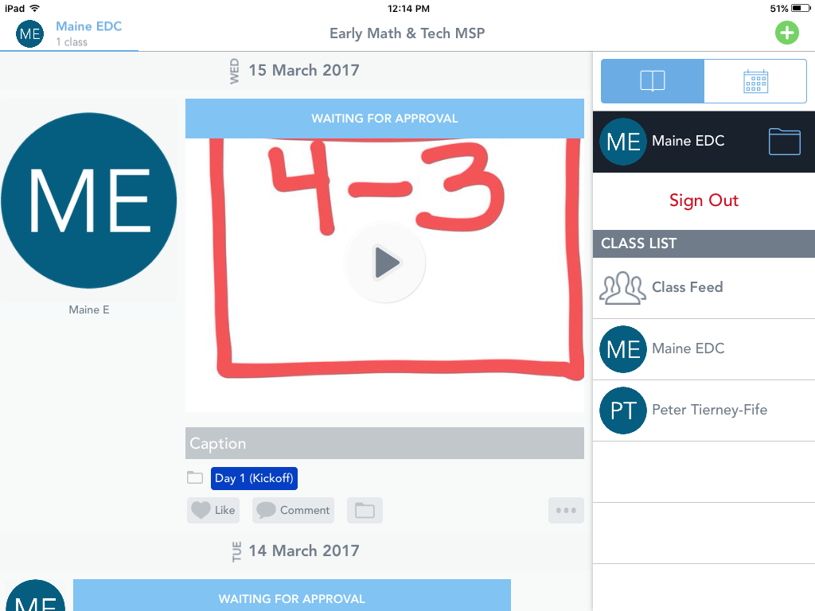

1. You can delete, copy, edit (for an imported video, you can only edit the caption), and change the people and the folder(s) for the item using the menu (click the 3 dots) and icons under the item; see the image describing basic navigation features on page 1 of this handout