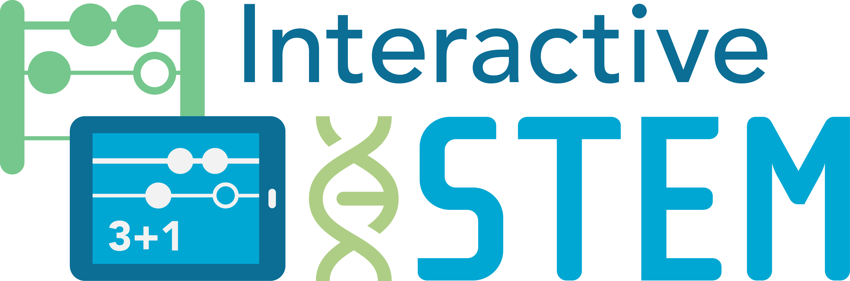
Early Mathematics and Technology Math Science Partnership
Interactive Technologies in STEM Teaching and Learning
Sharing Protocol with Notes Template
Background
Sharing and discussing videos of students solving math problems was a key part of meetings during the research and practice collaboration in Auburn, Maine, which was the basis for many of the resources in the Early Math and Technology Math Science Partnership project. The partners in the Auburn collaboratory—K-2 teachers, technology integrators, school and district administrators, university faculty, and researchers—gathered to study how to best integrate mobile technologies in mathematics lessons to improve learning for early elementary students. They designed strategies to test in the classroom, collected and co-analyzed student work including student-made videos, and shared and discussed their learning.
The partners followed a protocol to share and discuss student work, focusing on self-recorded student videos made with screencasting apps on mobile devices such as Explain Everything™. Following the protocol, each teacher in turn described the context of their lesson's goal and math problem, important information about their student (for example, how the student had performed on math problems in the past), and showed the video the student created as she/he solved the math problem.
Sharing in this way helped the partners discuss and develop their content knowledge, pedagogical content knowledge, and technological pedagogical content knowledge in a potentially less threatening way than dissecting a teacher's practice in a classroom video. The focus on student thinking, discourse, and approaches to solving mathematics problems supported collaboration among partners with different roles and invited multiple perspectives, including about how to interpret the evidence in the videos and about possible implications for refining the strategies and approaches to improve student learning.
The protocol on the next page is a simplified version of the protocol used during the research and practice collaboration in Auburn, Maine. The original protocol is included in the document named Tools for Educators: Strategy Sharing Protocol and it can be found at http://interactivestem.org.
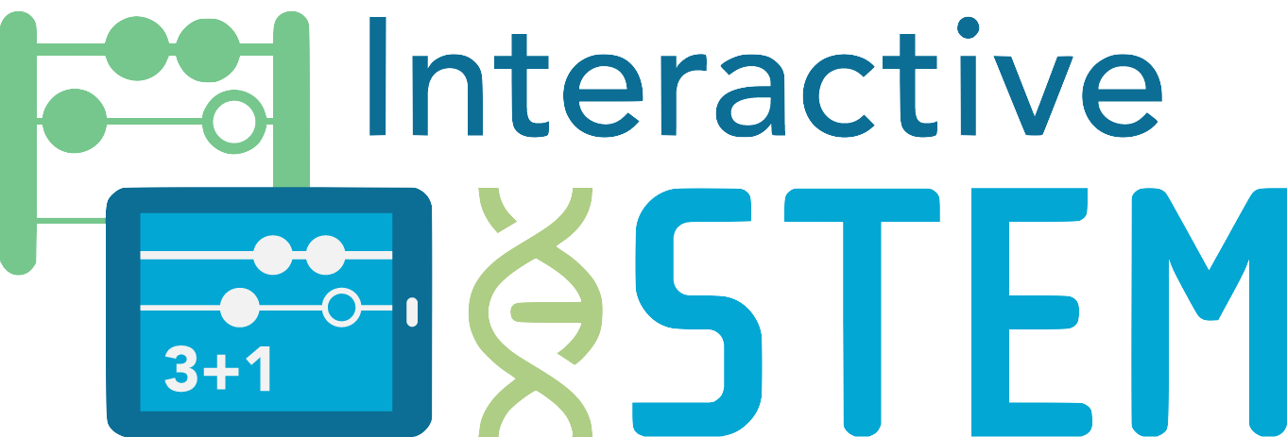
I. Presentation (2-3 minutes)
Interactive Technologies in STEM Teaching and Learning
Sharing Protocol
The presenter shares brief background information about the artifact and a reflection.
Example sentence starters you can choose to use:
- My goals for the activity were…
- The strategy I tried was…
- I’m sharing this student’s work because….
- From this activity, I learned….
- I’m left wondering…
II. Group Discussion (3-6 minutes)
The group discusses the presenter's information and offers thoughts and reflections.
Example questions to consider and discuss:
- In what ways can this strategy/resource make a difference for students’ mathematics learning?
- For whom can it make a difference?
- Under what conditions can it make a difference?
- What might be instructional next steps?
(Repeat this process for each person sharing.)

Interactive Technologies in STEM Teaching and Learning
Sharing Protocol Notes Template
Presenter Name | Description  What was tried?  What was the context? | Reflections/Key Learning(s)  What did I learn from this presentation?  What are the key ideas that can inform my work in the future?
Additional Notes

