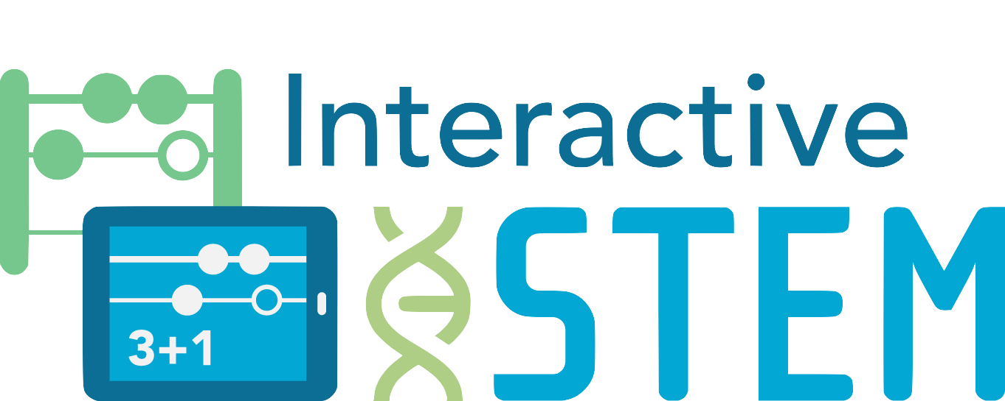

Interactive Technologies in STEM Teaching and Learning

research + Practice Tool

# Reading Reflection

Respond to the three prompts below about your reading.

This document is created by Education Development Center, Inc. Copyright 2017. Funded by a Maine Mathematics and Science Partnership Project (RFP# 201610203). Opinions expressed in this brief are those of the contributors and not necessarily those of the Maine Department of Education. Learn more at [interactiveSTEM.org](http://interactivestem.org/).



|  |  |  |
| --- | --- | --- |
| **What?**  Explain what the reading is about. | **So What?**  What does this reading have to do with the learning and teaching of mathematics in technology-rich classrooms? | **Now What?**  What next? How will you incorporate your idea(s) into your mathematics teaching and learning? |