PreK-6 Math Apps – Notes Sheet
App Name | Description |  | Notes
Classic Explain Everything | Interactive whiteboard that can record audio, writing, typing, photos, video, and other media
Apps from the Math Learning CenterTM are free, and online versions can be accessed through a computer’s browser.
See: http://catalog.mathlearningcenter.org/apps
Number Rack | Facilitates the natural development of children’s number sense. Rows of moveable, colored beads
The Number Line  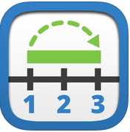 | Model strategies for addition, subtraction, multiplication, and division
Number Pieces  Basic  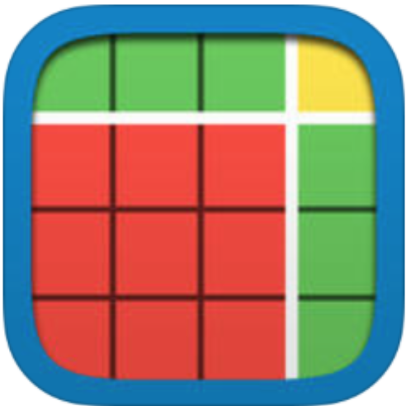 | Helps build skills with computation of multi-digit numbers  Includes drawing tools
Number Pieces | Helps build skills with computation of multi-digit numbers  Includes drawing tools
Number Frames  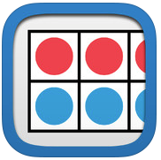 | Helps students structure numbers to five, ten, twenty, and one hundred
Money Pieces | Helps students understand and use U.S. coins and dollar; connects with number pieces (one, ten, flat)
Pattern Shapes | Supports students’ geometric thinking and representation.
Geoboard | Supports students’ geometric thinking and representation
Apps from First 8 Studios are the product of a research-based project funded by the National Science Foundation and WGBH. There are free downloadable apps plus downloadable hands on materials and teacher support materials. There are 4 focused on equipartitioning and 4 focused on subitizing.
http://first8studios.org/
App Name | Description |  | Notes
Gracie and Friends Birthday Cafe | Number sense  Game based tools for Pre-K
Gracie and Friends City Skate | Number sense  Game based tools for Pre-K
Gracie and Friends Treasure Bubbles | Number sense  Game based tools for Pre-K
Gracie and Friends Jungle Gym  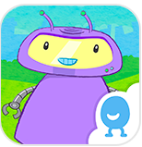 | Number sense  Game based tools for Pre-K
Gracie and Friends  Lemonade Stand  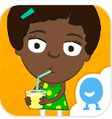 | Number sense  Game based tools for Pre-K
Gracie and Friends  Breakfast Time  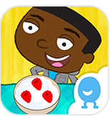 | Number sense  Game based tools for Pre-K
Gracie and Friends  Park Play | Number sense  Game based tools for Pre-K
Gracie and Friends  Photo Friends | Number sense  Game based tools for Pre-K
The following apps support the reinforcement of the models and tools that are the primary focus of the toolkit.
Most are free and many are developed by “Classroom Focused Software”. These tools are targeted and provide the opportunity for customization.

http://www.classroomfocusedsoftware.com/math.html
App Name | Description | Notes
Quick Images  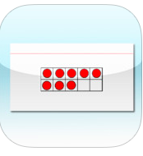 | The Quick Images app provided images of representations of numbers from 1 to 20 including 10 frames, 20 frames, arithmetic rack, hands, and dot cards.
Count Sort  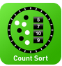 | Students complete number lines with some of the numbers provided
10 Frame Fill  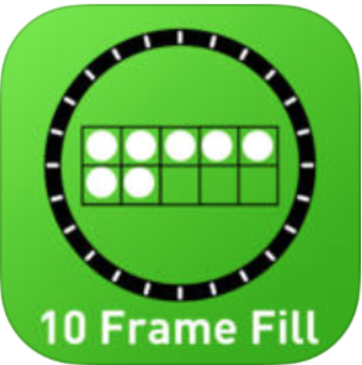 | Ten Frames help students represent addition with totals of 10
Line ’em Up  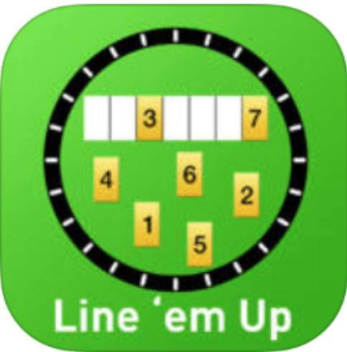 | Students complete number lines with some of the numbers provided
Number Bond Blasters  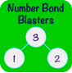 | Students complete number bonds with some of the numbers provided
Domino 10 Frame  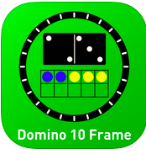 | Domino 10 Frame supports students making connections between the 10 frame tool, dominoes, and number sentences
Number Line Math K2  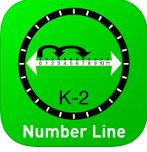 | Students use number lines to solve problems, includes jumps
Thinking Blocks Addition  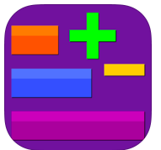 | Students use models to set up and solve addition and subtraction problems
* Note – Subitizing is looking at a group of objects and instantly seeing how many there are without counting.

