

Interactive Technologies in STEM Teaching and Learning

# Open Task

# Factors and Multiples

Grade 6 Operations and Algebraic Thinking

Topic: Factors and Multiples

Task BackgroundMacintosh HD:Users:rcheung:Desktop:Interactive Stem Brief_Ready for Robin:Links:EDC Color Logo.eps

The task presents an opportunity for students to solve a factor problem using a visual representation. Example representations and/or tools could include a number line or 10-frames app.

Content Standards

* Gain familiarity with factors and multiples.
* Find all factor pairs for a whole number in the range 1-100. Recognize that a whole number is a multiple of each of its factors. Determine whether a given whole number in the range 1-100 is a multiple of a given one-digit number.

Practice Standards

* *Make sense of problems and persevere in solving them*  
  Students persevere using multiple representations for the number.
* *Model with mathematics*

Students create drawings (e.g., open number lines or other representations) or other representations to model the number.

Materials

Students can use paper and writing tools, concrete and/or virtual manipulatives, and/or a screen-recording app.

**Finding Multiples Problem 1**

Show 10 jumps of 3 on the number line.

Which numbers do you predict that you will land on that are also multiples of 6?

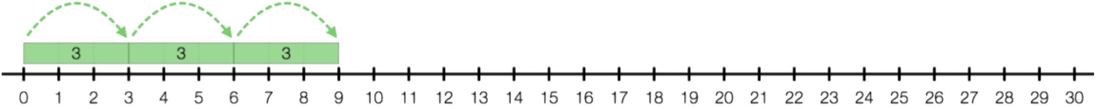

Show jumps of 6 on the bottom of the number line.

This document is created by Education Development Center, Inc. Copyright 2017. Funded by a Maine Department of Education contract (# 201708070513). Opinions expressed in this brief are those of the contributors and not necessarily those of the Maine Department of Education. Learn more at [interactiveSTEM.org](http://interactivestem.org/).

Circle the numbers that are both multiples of 3 and 6.

**Finding Multiples Problem 2**

Show 20 jumps of 3 on the number line.

Which numbers do you predict that you will land on that are also multiples of 5?

Use the number line to check your prediction.

Circle the numbers that are both multiples of 3 and 5.

Predict which numbers will be multiples of 5 and 9.

Explain your reasoning.

Check your predictions on the number line.

**Finding Multiples Problem 3**

Choose 2 numbers.

Predict the first 5 multiples of these two numbers. Explain your thinking.

Check your prediction on the number line.

**Finding Multiples Problem 4**

Choose 3 numbers.

Predict the first 2 multiples of these three numbers. Explain your thinking.

Check your prediction on the number line.