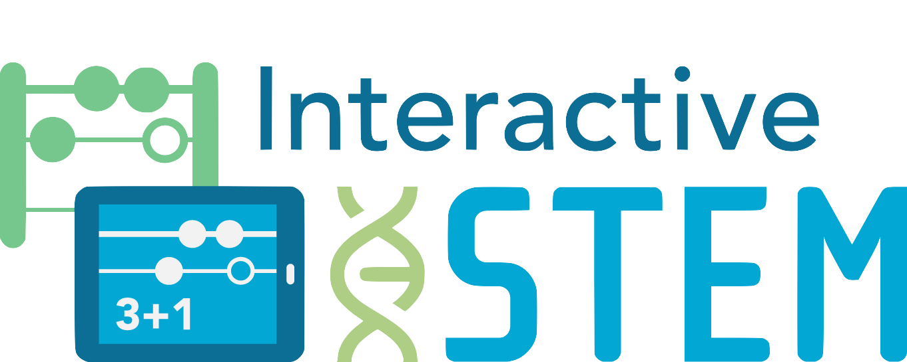

Interactive Technologies in STEM Teaching and Learning

Open Task

# Make 8

Grade K Number & Operations in Base Ten

Topic: Represent whole numbers within 10

Task BackgroundMacintosh HD:Users:rcheung:Desktop:Interactive Stem Brief_Ready for Robin:Links:EDC Color Logo.eps

This document is created by Education Development Center, Inc. Copyright 2017. Funded by a Maine Mathematics and Science Partnership Project (RFP# 201610203). Opinions expressed in this brief are those of the contributors and not necessarily those of the Maine Department of Education. Learn more at [interactiveSTEM.org](http://interactivestem.org/).

The task presents an opportunity for students to represent a number in multiple ways. The task asks students to create representations of 8. Example representations include the numeral 8 and addition or subtraction problems that result in 8, as well as appropriate visuals using a 10-frame, a number line, a number rack, etc.

Content Standards

* Represent whole numbers within 10
* Represent addition and subtraction with objects, fingers, mental images, drawings, sounds (e.g., claps), acting out situations, verbal explanations, expressions, or equations.
* Decompose numbers less than or equal to 10 into pairs in more than one way, e.g., by using objects or drawings, and record each decomposition by a drawing or equation (e.g., 5 = 2 + 3 and 5 = 4 + 1).

Practice Standards

* Make sense of problems and persevere in solving them  
  Students persevere using multiple representations for the number.
* Model with mathematics

Students create drawings (e.g., open number lines or other representations) or other representations to model the number.

Materials

Students can use paper and writing tools, concrete and/or virtual manipulatives, and/or a screen-recording app.

**Make 8**

Show as many ways to make 8 as you can.

**Make 8**

Show as many ways to make 8 as you can.

© 2017 Education Development Center, Inc. (EDC)



**Make 8**

Show as many ways to make 8 as you can.

© 2017 Education Development Center, Inc. (EDC)