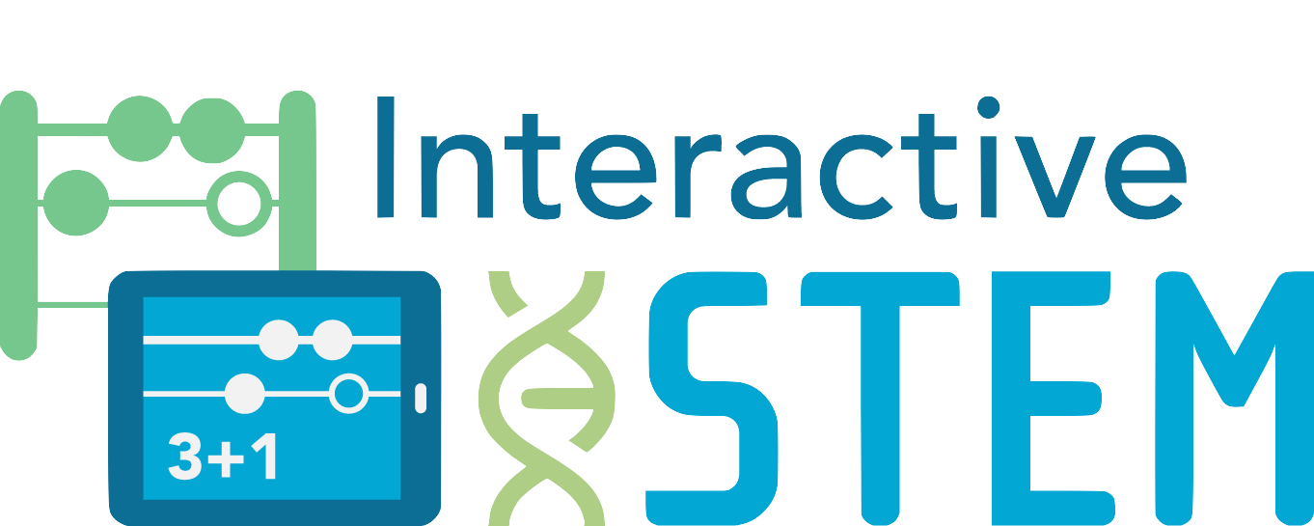

Interactive Technologies in STEM Teaching and Learning

Open Task

# Making Change

Grade 2 Measurement & Data

Topic: Problem solving with money

Task BackgroundMacintosh HD:Users:rcheung:Desktop:Interactive Stem Brief_Ready for Robin:Links:EDC Color Logo.eps

This document is created by Education Development Center, Inc. Copyright 2017. Funded by a Maine Mathematics and Science Partnership Project (RFP# 201610203). Opinions expressed in this brief are those of the contributors and not necessarily those of the Maine Department of Education. Learn more at [interactiveSTEM.org](http://interactivestem.org/).

The task presents an opportunity for students to engage with the addition and subtraction of 3 digit numbers in the context of money. The task asks students to determine if the correct change is given back when buying multiple items. Students are also expected to provide an explanation of their reasoning.

Content Standard

* Solve word problems involving dollar bills, quarters, dimes, nickels, and pennies, using $ and ¢ symbols appropriately. Example: If you have 2 dimes and 3 pennies, how many cents do you have?

Practice Standards

* Make sense of problems and persevere in solving them  
  Students make sense of the problem context provided then they persevere using various addition and subtraction strategies to solve the problem. They then persist to make an explanation of the solution and share the strategy they used to justify their answer.
* Model with mathematics

Students create drawings (e.g., open number lines or other representations) to model and solve word problems involving money. Students organize their thinking about money by modeling with dollars and coins to solve the word problem using addition and subtraction.

* Construct viable arguments and critique the reasoning of others  
  Students can construct arguments using concrete referents such as objects, drawings, diagrams, and actions. They can listen or read the explanations of others, decide whether they make sense, and ask useful questions to clarify or improve the arguments.

Materials

Students can use open number lines, hands-on manipulatives (coins & bills), apps such as Money Pieces (© The Math Learning Center), or paper and writing tools.

**Making Change**

I went to the coffee shop on the way to school. I bought a bagel with cream cheese and a coffee. The bagel cost $2.44 and the coffee was $1.99

When I gave the cashier a $5.00 bill, she gave me back 2 quarters, 1 dime, 1 nickel, and 2 pennies.

Did she give me the correct change? Explain how you know.

**Making Change**

I went to the coffee shop on the way to school. I bought a bagel with cream cheese and a coffee.

The bagel cost $2.44 and the coffee was $1.99.

When I gave the cashier a $5.00 bill, she gave me back 2 quarters, 1 dime, 1 nickel, and 2 pennies.

Did she give me the correct change? Explain how you know.

© 2017 Education Development Center, Inc. (EDC)



**Making Change**

I went to the coffee shop on the way to school. I bought a bagel with cream cheese and a coffee.

The bagel cost $2.44 and the coffee was $1.99.

When I gave the cashier a $5.00 bill, she gave me back 2 quarters, 1 dime, 1 nickel, and 2 pennies.

Did she give me the correct change? Explain how you know.

© 2017 Education Development Center, Inc. (EDC)