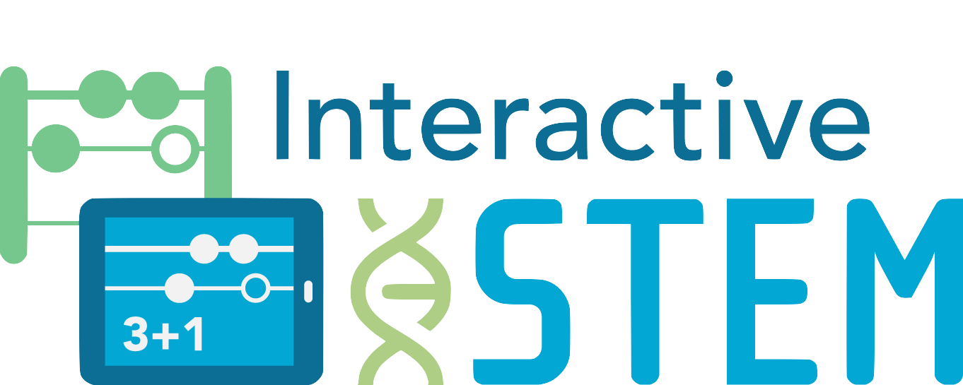
Interactive Technologies in STEM Teaching and Learning
Task with App Application

Modeling Multiplication Grade 3 Operations and Algebraic Thinking
Topic: Represent and Solve Problems Using Multiplication
Content Standards
- Operations and Algebraic Thinking
- Represent and solve problems involving multiplication and division.
- Understand properties of multiplication
Practice Standards
- Make sense of problems and persevere in solving them
Students persevere to understand and solve the problem.
- Model with mathematics
Students create representations and number sentences associated with the problem.
- Use appropriate tools strategically
Students use tools and/or hands-on manipulatives to show or create representations associated with the problem.
Samantha’s Savings
Samantha saved $12 per week during the summer. How much money did she save in 7 weeks?

How can this problem be modeled?

Is there an app that can be used to model this problem? If so, which app would you use? Why?

Choose an app and model the problem.

Samantha’s Savings
Samantha saved $12 per week during the summer. How much money did she save in 7 weeks?

How can this problem be modeled?

Is there an app that can be used to model this problem? If so, which app would you use? Why?

Choose an app and model the problem.

© 2017 Education Development Center, Inc. (EDC)
Samantha’s Savings
Samantha saved $12 per week during the summer. How much money did she save in 7 weeks?

How can this problem be modeled?

Is there an app that can be used to model this problem? If so, which app would you use? Why?

Choose an app and model the problem.

© 2017 Education Development Center, Inc. (EDC)

