Interactive Technologies in STEM Teaching and Learning
Task with App Application

Multiplying Fractions String Grade 5 Number and Operations - Fractions
Topic: Apply and extend previous understandings of multiplication and division.
Content Standards
- Number and Operations - Fractions
- Interpret the product (a/b) × q as a parts of a partition of q into b equal parts
Practice Standards
- Model with mathematics
Students create representations and number sentences associated with the problem.
- Use appropriate tools strategically
Students use tools and/or hands-on manipulatives to show or create representations associated with the problem.
- Look for an make use of structure
Students look closely to discern a pattern or structure
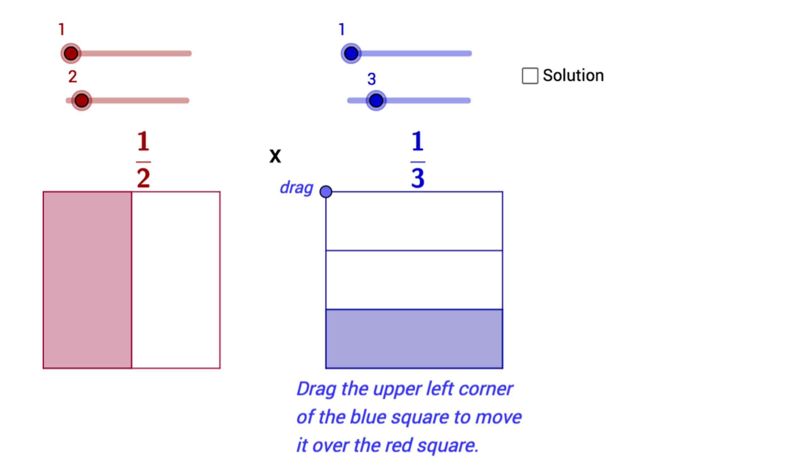
Related Technology Tool
This activity can be used with the Multiplying Fractions - Area Model applet at:
https://www.geogebra.org/m/NZQ5dBrG
One way to use the tool is to have students explore the tool and example problems before completing their predictions and explanations. Below are some possible features to explore when using the tool:
- Drag the horizontal sliders for the fractions
- Select the Solution check box
- Click and drag the blue dot on the corner of the blue square to move it over the red square
You can have students complete the table on the next page and then follow the steps below:
- Uncheck the Solution check box
- Drag the blue dot to the right
- Drag the read and blue sliders to represent the fraction values for the specific problem
- Review your prediction and explanation for the problem
- Check the Solution check box and drag the blue dot to the left; compare the number and visual result with your prediction

Multiplying Fractions
Fractions to multiply | Prediction  (number and/or visual) | Explain your reason  for your prediction
$\frac{1}{3}$ and $\frac{1}{4}$
$\frac{1}{4}$ and $\frac{4}{5}$
$\frac{4}{5}$ and $\frac{2}{3}$
$\frac{2}{3}$ and $\frac{3}{4}$
Review your predictions and reasons, possibly with a partner, an app, or your teacher.
How did your predictions and reasons relate to the number and visual answers you compared to them?

Write your own fraction multiplication problem and describe how you can use a visual model to find and understand the result.

